# Welcome to Excitor DME!

DME helps you stay connected with your corporate e-mail, calendar, and contacts any time. What you see on your iOS device is what you have on your desktop or laptop computer at the office.

DME completely secures the business data on your device – so if you lose it or it is stolen, you can be certain that nobody can get to your data.

This guide for DME for Apple iOS applies to all supported iOS devices. Note that the illustrations are taken from an iPhone – the corresponding screens look slightly different on an iPad, but the functionality is the same.

## Getting started with DME

To start using DME, you need to get the DME app from Apple App Store first.

1. Open the Apple App Store in iTunes on your iOS device. Search for "DME 4" using the search box.

*or*

1. Go directly to the DME client download page in the App Store by typing **http://itunes.com/app/dme4** in the Safari browser on your device, or by following a link sent to you by your DME Administrator.
2. Tap the **FREE** button. The button transforms to an **Install** button.
3. Tap **Install**.
4. Enter your iTunes password when prompted, and wait for the application download to complete.

You could also download the DME app using iTunes on your PC or Mac, and then synchronize DME to your iOS device.

To keep DME handy at all times, you can move the DME app to the iOS ribbon. To do this, press and hold any app icon in the Home screen, until the icons begin to wiggle. Then drag an icon away from the ribbon, and drag the DME app icon to the open space in the ribbon. Click the **Home** button to exit Home screen edit mode.

*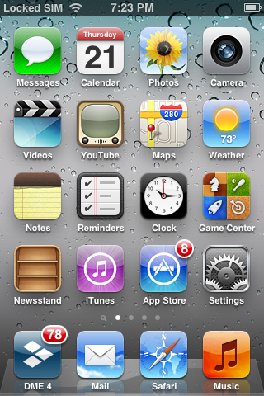*  
*DME in the iOS ribbon*

Tap the DME icon to launch DME for the first time. DME needs to know some facts before it is able to start synchronizing your e-mail, calendar, and contacts, and prompts you to enter some information. This information has probably been sent to you by your DME administrator – otherwise contact him or her.

1. First you are asked if you want to enable notifications for this program. You should do this in order to receive notifications of new e-mails etc.
2. DME then asks you for the *server path*. The server path has the form **dme.yourcompany.com:5011**, where **dme.yourcompany.com** is the host name of the server where DME is installed, and **:5011** is the port number.

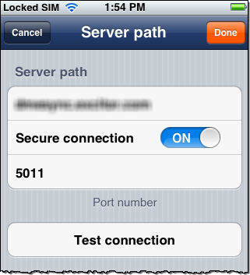

*DME Server path screen*

Usually you only need to enter the path – the port number is set to default **5011**, and the **Secure connection** switch inserts the **https://** part of the path for you.

You can use the **Test connection** button to verify that you entered the path correctly.

1. Tap **Done**.
2. If your device has a phone module (iPhone and some iPads), DME will ask you what your phone number is. Apps are not permitted to find the phone number automatically, so that is why DME needs you to enter it. You can enter the phone number later if you like.
3. When you tap **Done**, DME shows the **Login** screen.
4. Enter you username and your password. These are the same username and password that you use to log in to your network.

If you are using Lotus Notes on your desktop computer, you need to enter your “Internet password”. Contact your IT department if you have problems with your username or password.

1. Tap **Login**.

DME connects to the server you specified in the **Server path** screen. If your username and password were correct, DME is initialized for first use. (*Note*: In some secure setups, the DME Administrator requires a manual verification process before you can start synchronizing.)

This means that DME will start *importing* your corporate e-mail, calendar, and contacts (and more) to DME on your device. Your DME administrator has set up an initial profile for you, which controls the number of e-mails and events that are imported to and kept synchronized with your device, expressed as a number of days. For instance, you can get your e-mails from 20 days back, and your calendar entries from 7 days back till 100 days into the future. This is called the *sync window*. **Notes users:** See important note at the end of this guide about **Lotus Notes encrypted e-mail.**

After this process is complete, you have access to your corporate data from your device, and you can start using your e-mail, calendar, contacts, and other resources synchronized by DME. You can access the different parts of DME from the DME Desktop:

*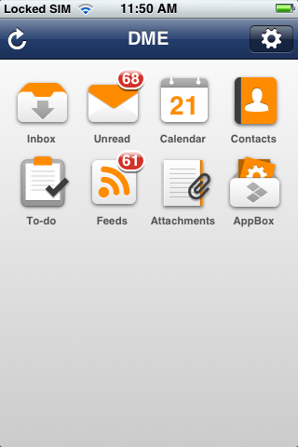* *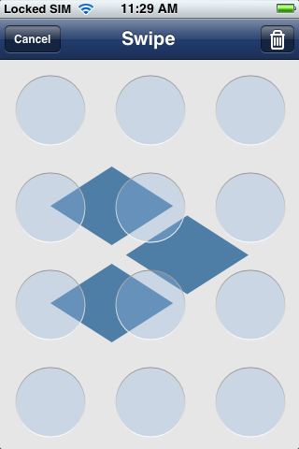  
The DME Desktop Rearrange Desktop icons Set swipe pattern*

The Desktop only shows icons for the features to which you have access. You can rearrange the Desktop icons by long-pressing the Desktop and move the icons around.

If you want to be able to log in without entering your full network password, there’s an easier way. Tap **Tools** from the **Desktop**, then **Set swipe code**. Define a swipe pattern by moving your finger vertically and horizontally across any of the 12 tiles on the screen. Repeat. The next time you log in to DME, you can use this swipe pattern for logging in instead of your full network password.

Note that your DME administrator has set up minimum requirements for the number of tiles you must swipe to create a valid pattern. Also, if you haven’t logged in for a while, you may need to log in using your full network password (but after that, you can use the swipe pattern again).

For more information, see the full **DME for iOS User Guide** (available on the Web: <http://documentation.excitor.com>).

## E-mail

Tap the **Inbox** icon on the Desktop to access your corporate e-mail. C:\AIT Data\Publishing\Word Document New Design\Apple iOS 4.0\icon_inbox_home.png A badge shows how many unread messages you have in the Inbox.

Just below the name of the folder, you can see the total number of e-mails in the current folder and the number of unread e-mails in the folder. You can tap that area to sort your e-mails differently.

The received time of the e-mails is shown as a time of day when received today, and as a day in the week for e-mails received during the past week. E-mails received before that show with the full received date.

Drag up/down, or flick to see more e-mails. If at the top of the mailbox, you can drag down and then release to synchronize the mailbox (Twitter-style sync.):

*Twitter-style sync*

It is good practise to perform an e-mail sync after carrying out mailbox management functions, such as deleting e-mails or moving e-mails to folders. DME automatically synchronizes when you send e-mails and meeting invitations.

Each e-mail has an icon that tells you about its status.

|  |  |  |  |  |
| --- | --- | --- | --- | --- |
| Icon | Meaning | | | |
|  | An unread e-mail. The sender is displayed in a **boldface** font. | (no dot) | | An already read e-mail. |
|  | You have replied to this e-mail. |  | You have forwarded this e-mail. | |
|  | This e-mail has attachments. |  | This is a meeting invitation. | |
|  | This means that you have marked the e-mail for follow-up. | | | |

Tap an e-mail to read it. The e-mail view contains a number of functions:

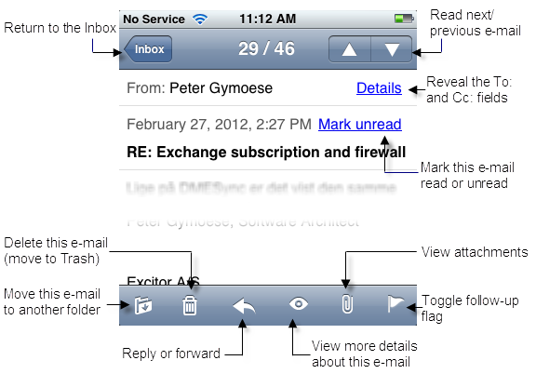

In the e-mail body, you will often see underlined text – those are links. DME creates links to web addresses, e-mail addresses, and phone numbers. Clicking a web link from an e-mail opens the link in a web browser – either Safari or the AppBox browser (more about this later). Clicking an e-mail address or phone number lets you decide what to do – either create an e-mail or place a call, add a new contact, or update an existing contact.

If the e-mail contains attachments, you can click the paper clip icon to see a list of those attachments. You can open an attachment from the list. Note that the attachment is not saved outside the secure DME container when it is opened, so you cannot accidentally leak sensitive data to the device. However, your DME administrator may have allowed you to print or open the attachment in another application.

### Composing and sending an e-mail

Tap the **Compose e-mail** icon from any folder: [](F_3170)

Select recipients in the **To**, **CC**, and **Bcc** fields. DME helps you by showing a list of known contacts as you start typing:

This list of known contacts derives from your local Contacts and from e-mail addresses you have used recently.

Alternatively, you can tap the search icon [](F_6122) to search for contacts in the Global Address Book (your company directory).

When a recipient has been entered, it is enclosed in an address bubble so it is easy for you to see how many recipients there are:

The bubbles are shown while you edit the field in question.

Using the three grey icons floating above the keyboard, you can:

* Set e-mail details (Importance and Security options)
* Add and manage attachments
* Hide the keyboard

When you have entered recipients, a subject, and a message, tap **Send** to dispatch the e-mail. DME starts synchronizing with the server, delivering your new message and receiving any new messages that may have arrived.

## Contacts

If Contact synchronization is enabled, DME will manage a copy of your local address book from Outlook or Lotus Notes on your device. Whenever a contact is added, removed, or edited on the device, the changes are synchronized with Outlook or Lotus Notes – and vice versa.

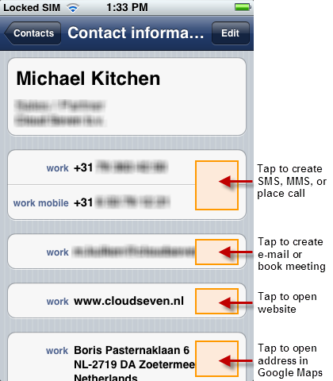By default, the contacts are stored securely within DME, and are accessible by tapping the **Contacts** icon from the **Desktop**: C:\AIT Data\Publishing\Word Document New Design\Apple iOS 4.0\icon_contacts_home.png You can view and edit your contacts. When viewing a contact, you can easily place a call, create an SMS or MMS message for, create an e-mail for, or book a meeting with the person in question. You can also open a website or look up the contact’s address in Google Maps, as shown in the illustration on the right:

If you need your business contacts in the device **Contacts** app as well, you can let DME synchronize your contacts with the local device contacts. When you do this, all your contacts are copied out into a contact group called **DME** and are kept synchronized with your contacts in DME. This way, you can use your business contacts without having to log in to DME. Note that keeping a local copy in the **DME** group in your device Contacts app is not possible if you also synchronize contacts through iCloud. For more information, see the chapter **Interaction with the device Contacts** in the full **DME for iOS User Guide**.

## Calendar

DME contains a fully featured, secure Calendar. Open the calendar by tapping the **Calendar** icon on the **Desktop**:

The Calendar has four views: **Month**, **Day**, **Week**, and **List** view. These views are shown below:

***Month*** *view,* ***Day*** *view,* ***Week*** *view, and* ***List*** *view*

To see the **Week** view, rotate your device.

In the **Day** and **Week** views, the events shown are color-coded according to their type:

* **Green:** Personal event (no other participants).
* **Blue:** Accepted meeting.
* **Red:** Tentatively accepted meeting.
* **Gold:** All-day event.
* **Gray:** If you have chosen to also show personal calendar events in DME, these events from other calendars in your device Calendar app are shown in gray.

In the **Month** view, entries from your local calendar are shown in the color selected for the calendar in question in the device Calendar app.

To book a meeting (add an event), tap the **Add event** button (the ) from the Calendar.

Complete the required fields. Adding participants works in the same way as for e-mails. You can also book rooms and resources, if your system administrator has made these items available.

After selecting participants, rooms, and resources, you can tap the **Check free time** button to see if they are all available, and optionally select a new date or time for the meeting.

You can choose to make a meeting recurring at fixed intervals, and you can set an alarm for yourself. You can also can mark the event Private, if you don’t want other people to be able to see the contents of the event in your Outlook or Notes calendar.

When you are done, tap **Send**. Invitations are sent to all participants, and the event is added to your own calendar.

Meeting invitations are received in the **Inbox**. When you open an invitaition, the features that you know from Outlook or Notes are available. You can **Accept**, **Decline**, **Delegate**, or **Tentatively accept** the meeting, or you can **Propose new time** (*counter*) the meeting.

Just as for Contacts, you can make your business calendar available in the device Calendar app. If you do this, the events from your DME calendar are *copied to* a calendar called DME in the device Calendar app. The events must be maintained from DME or from Outlook/Notes.

Before you do this, we recommend that you consult your DME administrator and read the chapter **Interaction with the device Calendar** in the full **DME for iOS User Guide**.

## Other features

Apart from e-mail, calendar, and contacts, DME can serve other functions – depending on your license and the settings defined by your DME administrator.

C:\AIT Data\Publishing\Word Document New Design\Apple iOS 4.0\icon_todos_home.png**To-dos**: Tapping the **To-do** item on the Desktop opens a list of the to-dos created on the collaboration system or in DME. You can filter the list to show **Incomplete** to-dos only (standard view) or **All** to-dos.

C:\AIT Data\Publishing\Word Document New Design\Apple iOS 4.0\icon_feeds_home.png**RSS Feeds**: With the RSS feeds feature, your DME administrator can set up RSS feeds that are synchronized to your device. This could for instance be a feed from a news site or an internal CRM database.

C:\AIT Data\Publishing\Word Document New Design\Apple iOS 4.0\icon_notes_home.png**Notes**: If you are using Lotus Notes, you can synchronize your personal *notes* (formerly known as *journals*) with the device.

**C:\AIT Data\Publishing\Word Document New Design\Apple iOS 4.0\icon_files_home.pngAttachments**: This view contains a list of all attachments referenced by e-mails, events, or to-dos on the device. You can for instance choose to download all attachments to make sure they are available to you offline (during a flight, for instance).

C:\AIT Data\Publishing\Word Document New Design\Apple iOS 4.0\icon_appbox_home.png**AppBox**: Open the **AppBox** Launchpad. See below.

## DME ApPBox

DME AppBox is a kind of secure corporate App Store. With DME AppBox, your company can push applications built with HTML5 technology and regular websites to the DME client. The users can then open these apps and websites securely, knowing that no data can be leaked outside the safe DME area on the device.

When you tap the AppBox icon from the Desktop, DME will connect to the AppBox server. When a connection has been established, DME shows the *AppBox Launchpad*. DME comes with a standard Launchpad, but it may be customized or completely replaced according to your company's needs and design wishes.

Furthermore, not everybody in the company gets the same AppBox Launchpad. The apps can be configured in many ways. For instance, an app can be configured to be shown on iPads only, or it can be configured to only be shown to a certain group of users.

The default AppBox Launchpad might look something like the example below:

Tap an icon to launch an app. All AppBox apps run within the *DME secure browser*. For more information, see the full **DME for iOS User Guide**.

## Lotus Notes encrypted e-mail

In order to send and receive Lotus Notes encrypted e-mail, DME needs to know your **Notes ID password**. Enter it by selecting **Tools > Settings > Security > Private key password**. If DME has already synchronized e-mail prior to this step, you must tap **Tools > Reset**, andconfirm that you wish to re-import your DME data. This is to ensure that all Notes encrypted e-mails are displayed correctly on your device. If you do not **Reset** DME, you will not be able to read any Notes encrypted e-mails received before you entered your Notes ID password.

## More information

The complete User Guide for DME on iOS can be found on the Web at: <http://documentation.excitor.com>.

This Quick Guide applies to DME for Apple iOS version 4.0 and above.

This Quick Guide was published on 31-07-2012.

 Copyright © 2007-12 Excitor. All rights reserved. Description: C:\Users\NIF.HEADQUARTERS\Pictures\DME\DME_logo\blue_orange\excitor_DME_logo_blue_orange_small.png

If you find any problems in the documentation, please report them to us through our customer support services. Excitor does not warrant that this document is error-free. Furthermore, Excitor does not warrant that the illustrations and screenshots used in this document reflect your version or the latest version of the program described.

DME is a trademark of Excitor. Microsoft Outlook is a trademark of Microsoft Corporation, registered in the U.S. and other countries. Lotus Notes® and Domino® are trademarks or registered trademarks of IBM Corporation, registered in the U.S. and other countries. Apple, Apple iPhone, iPod touch, and iPad are trademarks or registered trademarks of Apple Inc., registered in the U.S. and other countries. All other trademarks are property of their respective owners.