DME Quick Guide

DME 4.6 for Apple iOS

Document version 3.2

Published 10-05-2017

Contents

[Soliton 2](#_Toc482191791)

[How to get DME 3](#_Toc482191792)

[Getting started 4](#_Toc482191793)

[Log in screen 4](#_Toc482191794)

[Server path screen 5](#_Toc482191795)

[Welcome screen 6](#_Toc482191796)

[Phone number 6](#_Toc482191797)

[Set unlock pattern 6](#_Toc482191798)

[Set private key password 7](#_Toc482191799)

[Access your Contacts and Calendar 7](#_Toc482191800)

[Pre-registered device 7](#_Toc482191801)

[Using DME 9](#_Toc482191802)

[Desktop 9](#_Toc482191803)

[Rearrange icons 10](#_Toc482191804)

[Email 11](#_Toc482191805)

[Send email 11](#_Toc482191806)

[Email overview 12](#_Toc482191807)

[Search 13](#_Toc482191808)

[Folders 14](#_Toc482191809)

[Sort 15](#_Toc482191810)

[Email details 15](#_Toc482191811)

[Calendar 16](#_Toc482191812)

[Meeting invitations 16](#_Toc482191813)

[New event 17](#_Toc482191814)

[Contacts 17](#_Toc482191815)

[AppBox 18](#_Toc482191816)

[More 20](#_Toc482191817)

[Signed and encrypted email 20](#_Toc482191818)

# Soliton

Welcome to the DME Quick Guide for iOS. This guide contains a short introduction to the DME app.



Soliton Systems Europe  
Spotorno Allé 12  
2630 Taastrup  
Denmark  
Soliton website <http://solitonsystems.com/>

Some legal stuff:

DME is trademark of Soliton Systems.

Microsoft SQL Server®, Microsoft Exchange, Outlook®, Windows, Windows Server® 2003/2008/2012, and Active Directory® are trademarks or registered trademarks of the Microsoft Corporation in the United States and other countries.

Lotus Notes® and Domino® are trademarks or registered trademarks of IBM Corporation, registered in the U.S. and other countries.

Apple™, Apple iPhone™, iPod touch™, and iPad™ are trademarks or registered trademarks of Apple Inc., registered in the U.S. and other countries.

All other trademarks are property of their respective owners.

DME is in part developed and sold under license from Good Technology.

# How to get DME

This Quick Guide describes how things are normally done. If your company's DME Administrator tell you to do something else than is stated in this guide, do what your DME Administrator says.

1. Open the App Store app on your iOS device.
2. Search for DME using the search box. You are looking for the DME logo that looks like this:   
   C:\AIT Data\Publishing\Word Document New Design - Soliton\DME_Quick_Guide_iOS\dmeapplogo.png
3. Tap the GET button. The button transform into an INSTALL button.
4. Tap INSTALL
5. Enter your Apple ID password when prompted, and wait for the download and installation to complete.

# Getting started

## Log in screen

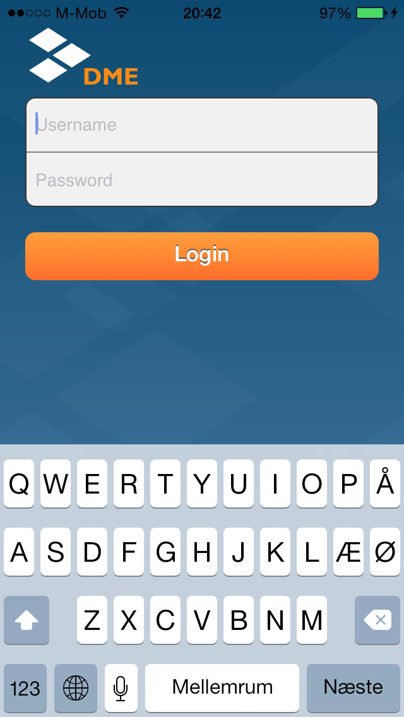

1. When you open DME for the first time, you are asked if you want to enable notifications. Tap OK, so you can get notified of new mails etc.
2. Then you are asked for your Username and Password.  
   Use the same Username and Password as you use for logging in to your desktop computer.  
   If you are a Lotus Notes user, use your internet password (same as your Notes Webmail password).  
   If you are in doubt, ask your company's DME Administrator.
3. Tap Login.

## Server path screen

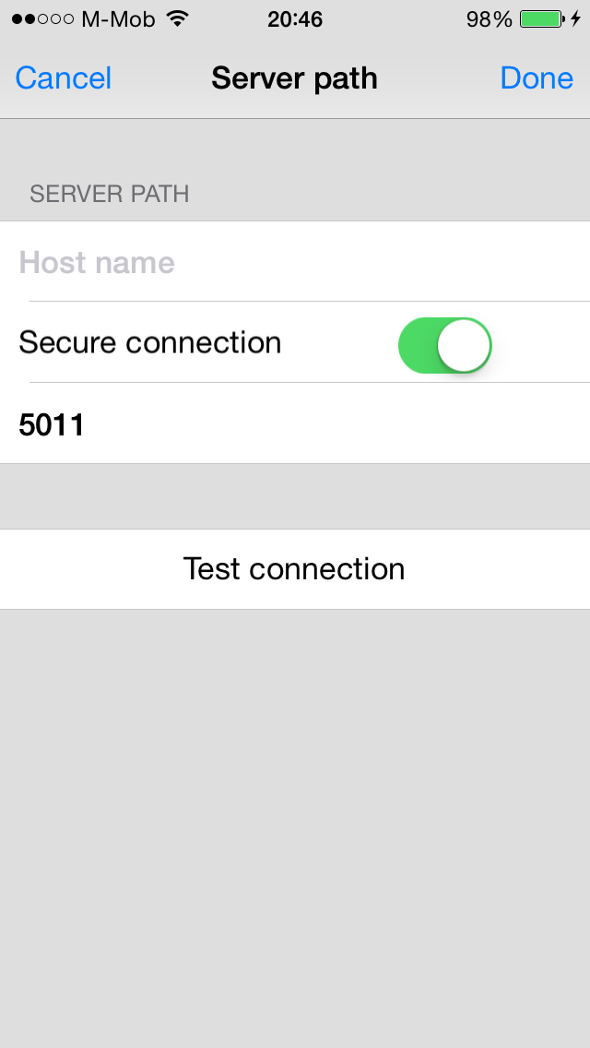

DME then asks you for information about the server path, particularly the Host name.

This Host name you need to get from your company's DME Adminstrator (it usually has the form dme.yourcompany.com).

1. Enter the Host name.
2. Tap Test connection to make sure it works and is typed correctly.
3. Tap Done.

## Welcome screen

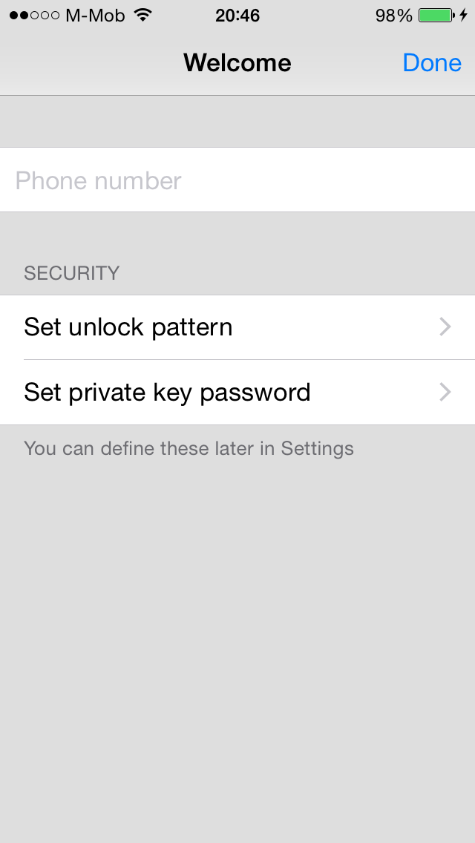

### Phone number

On this screen, you have the option of entering your phone number (without international calling code). This is optional, but can be of help to your DME Administrator.

### Set unlock pattern

This gives you the option of setting an Unlock pattern, which is a swipe code, you can use instead of having to type Username and Password.

1. Tap Set unlock pattern.
2. Define a pattern by moving your finger across the circles on the screen. The pattern must consist of at least 4 connected circles (connected either horizontal, vertical, or diagonal).
3. Then repeat the same pattern once more.

You can always set the pattern later: on the Desktop, tap Tools (the Gear icon),

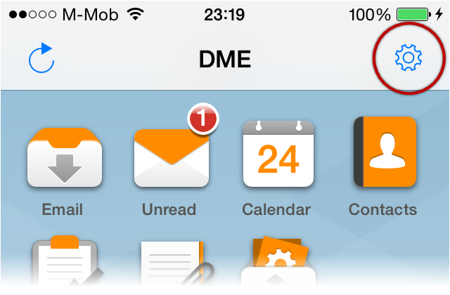

Then tap Set unlock pattern.

### Set private key password

This is used for encrypting and decrypting emails, and to sign private emails.

If you don't know what this is, or if no one has told you to fill this out, you can simply forget about it.

1. If you have a private key, tap Set private key password.
2. Enter the key.
3. Tap Done.

## Access your Contacts and Calendar

DME might ask you these questions:

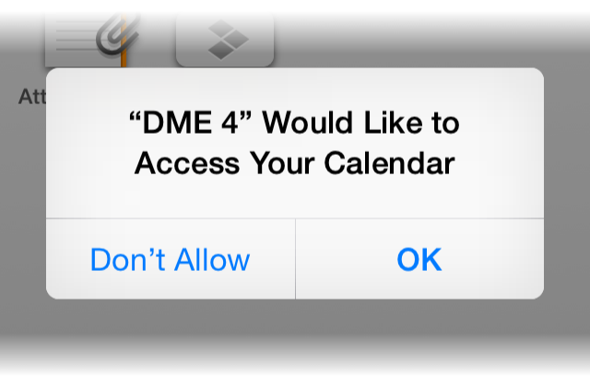 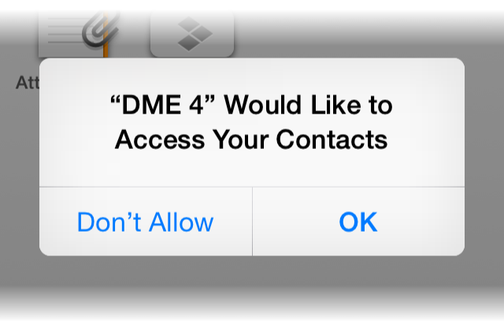

Tap OK to each of these.

## Pre-registered device

Some companies only allow already known devices. These are called pre-registered devices.

The means that you might get this message:

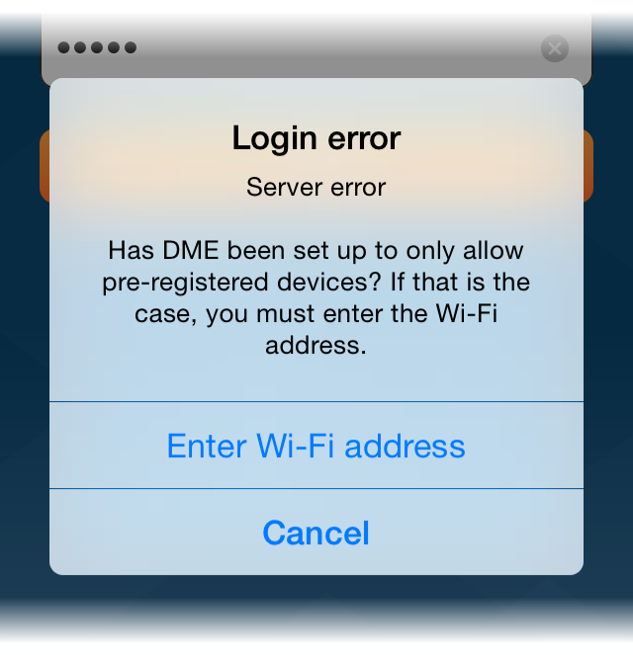

1. Tap Enter Wi-Fi address.
2. Exit DME, and open the iOS Settings app. Go to General > About. Long tap on the Wi-Fi Address, and tap Copy.
3. Go back into DME and paste what you copied into the text field  
   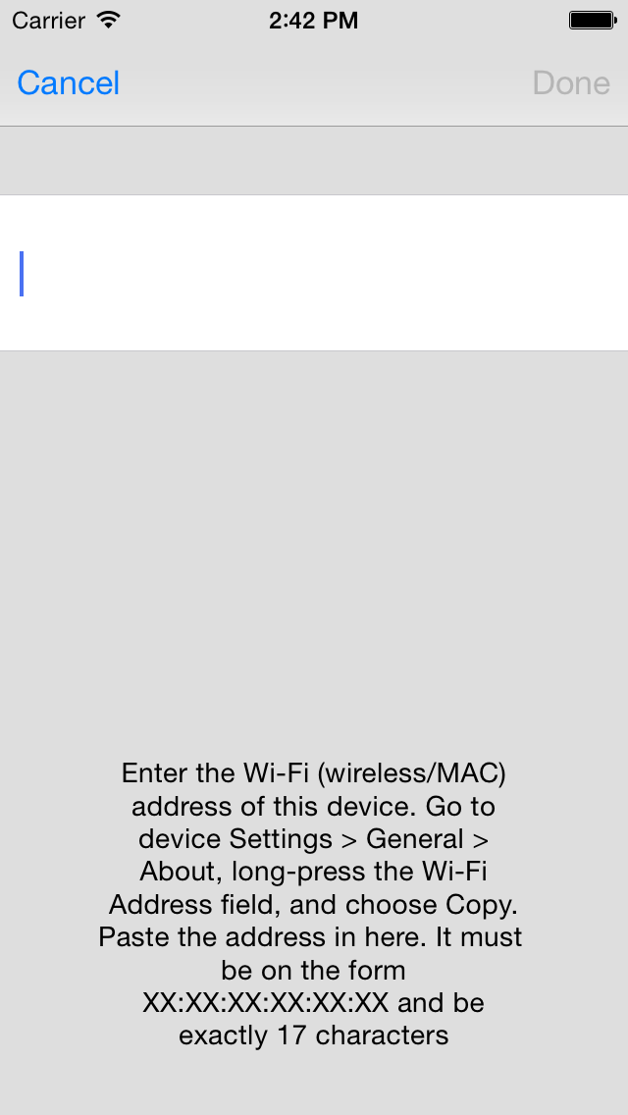
4. Tap Done.

# Using DME

You are now done setting things up, and DME will synchronize your Email, Calendar, Contacts, etc.

## Desktop

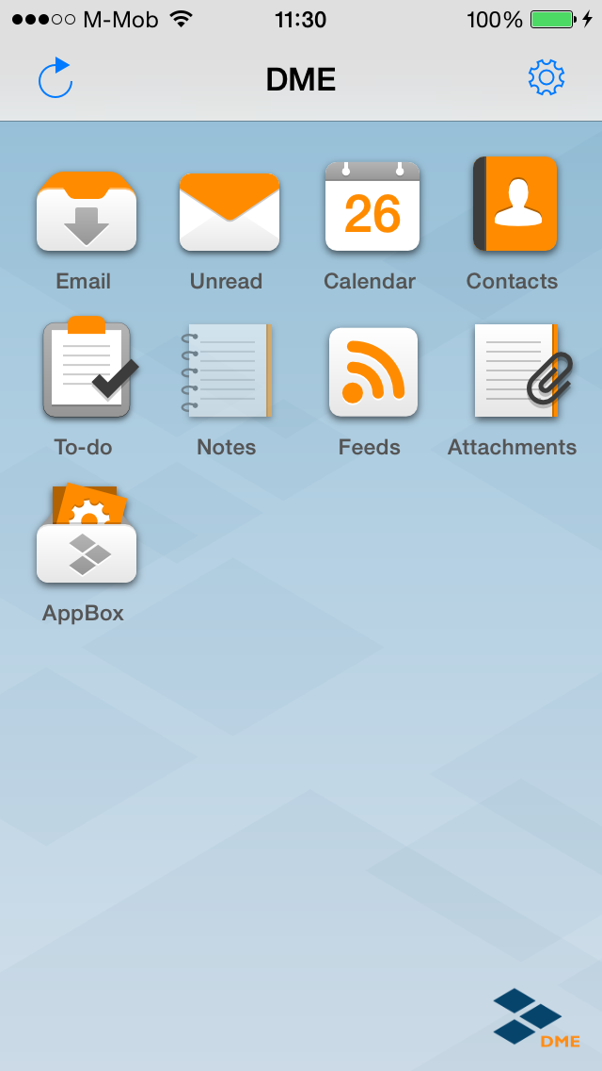

The DME Desktop shows the features you are allowed access to. These might include:

****Email - Access to your corporate email. See below.

****Unread - See your unread emails only. A badge on the Unread icon shows how many unread emails you have in the Inbox.

****Calendar - Access to your corporate calendar. See below.

****Contacts - Access to your corporate contacts. See below.

****To-do - The list of your to-dos. You can filter the list to show Incomplete to-dos only (standard view) or All to-dos.

****Feeds - RSS feeds. Your DME Administrator can set up RSS feeds that are synchronized to your device. This could for instance be a feed from a news site or an internal CRM database.

****Notes - If you are using Lotus Notes, you can synchronize your personal notes (formerly known as Journals) to the device.

****Attachments - Contains a view of all attachments from emails, calendar event, and to-dos on the device. You can choose to download all attachments to make sure they are available to you offline (if you need the during a flight, for instance).

****AppBox - Opens the AppBox Launchpad. See below.

### Rearrange icons

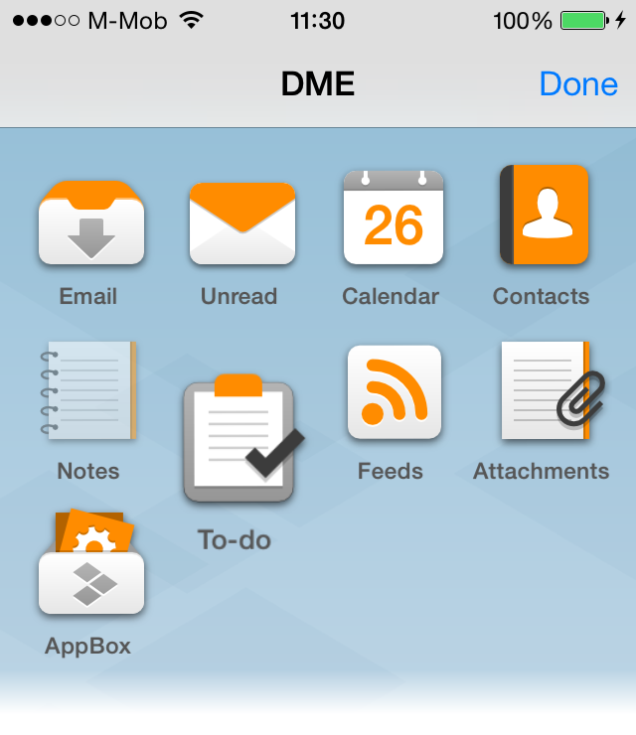

You can rearrange the icons by long-pressing and icon, and then move the icons around. Tap Done when you are finished.

## Email

To open email, tap the  Inbox icon on the Desktop.

A badge on the Unread icon shows how many unread emails you have in your Inbox.

If you tap the  Unread icon, you see your unread emails only.

If you want to go back to the Desktop, tap the C:\AIT Data\Publishing\Word Document New Design - Soliton\DME_Quick_Guide_iOS\home_button.png home icon.

### Send email

Tap the new email icon to begin a new email:

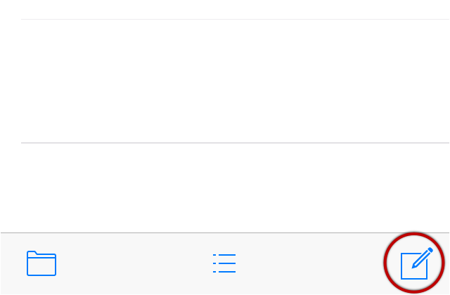

When you start typing To, Cc, or Bcc, DME will show you a list of matches from your local contacts and from recently used email addresses.

You can also tap C:\AIT Data\Publishing\Word Document New Design - Soliton\DME_Quick_Guide_iOS\magnifying-glass@2x.png search to search for contacts in your company directory (called Global Address Book).

Using the three grey icons floating above the keyboard, you can:

C:\AIT Data\Publishing\Word Document New Design - Soliton\DME_Quick_Guide_iOS\eyefloating.png Set email details (importance and security options)

C:\AIT Data\Publishing\Word Document New Design - Soliton\DME_Quick_Guide_iOS\clipfloating.png Add and manage attachments

C:\AIT Data\Publishing\Word Document New Design - Soliton\DME_Quick_Guide_iOS\keyboardfloating.png Hide the keyboard

If you tap Cancel, you have the option of saving the email as a draft. Tap Save and the mail is saved to the Draft folder.

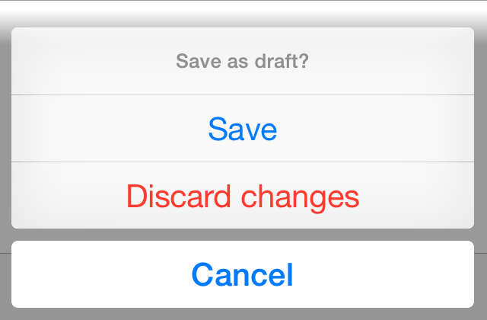

### Email overview

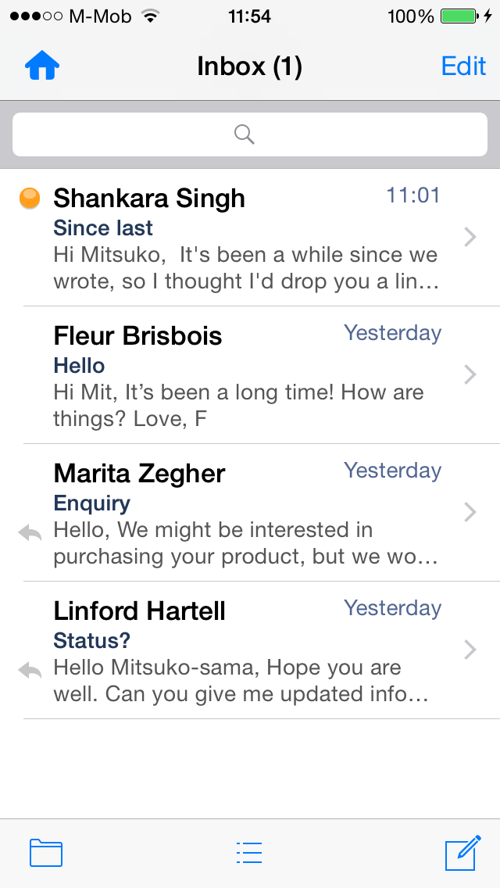

Tap on an email to see it.

The emails can have different icons:

C:\AIT Data\Publishing\Word Document New Design - Soliton\DME_Quick_Guide_iOS\emailoverviewiconunread.png The email is Unread.

C:\AIT Data\Publishing\Word Document New Design - Soliton\DME_Quick_Guide_iOS\emailoverviewiconattachment.png The email has Attachments.

C:\AIT Data\Publishing\Word Document New Design - Soliton\DME_Quick_Guide_iOS\emailoverviewiconflagged.png You have Flagged this email.

C:\AIT Data\Publishing\Word Document New Design - Soliton\DME_Quick_Guide_iOS\emailoverviewiconreplied.png You have Replied to this email.

C:\AIT Data\Publishing\Word Document New Design - Soliton\DME_Quick_Guide_iOS\emailoverviewiconforwarded.png You have Forwarded this email.

C:\AIT Data\Publishing\Word Document New Design - Soliton\DME_Quick_Guide_iOS\emailoverviewiconimportant.pngThe sender has marked this email as Important.

C:\AIT Data\Publishing\Word Document New Design - Soliton\DME_Quick_Guide_iOS\emailoverviewiconinvitation.png This is a Meeting invitation.

The bottom menu contains three buttons:

C:\AIT Data\Publishing\Word Document New Design - Soliton\DME_Quick_Guide_iOS\emailoverviewiconfolders.png Folders. Tap here to see your email folders. See below.

C:\AIT Data\Publishing\Word Document New Design - Soliton\DME_Quick_Guide_iOS\emailoverviewiconsort.png Sort. See below.

C:\AIT Data\Publishing\Word Document New Design - Soliton\DME_Quick_Guide_iOS\emailoverviewiconnew.png New email. Tap here to create a new email.

### Search

Tap C:\AIT Data\Publishing\Word Document New Design - Soliton\DME_Quick_Guide_iOS\searchfield.png Search field, and start typing your search.

If the email you are looking for aren't found on your device, you can tap Search on server:

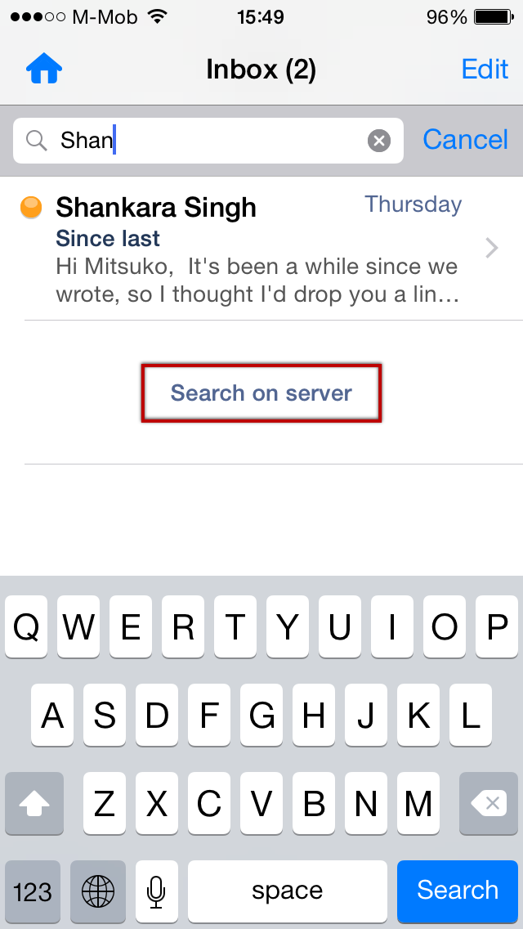

### Folders

Tap C:\AIT Data\Publishing\Word Document New Design - Soliton\DME_Quick_Guide_iOS\emailoverviewiconfolders.png Folders to see the list of folders:

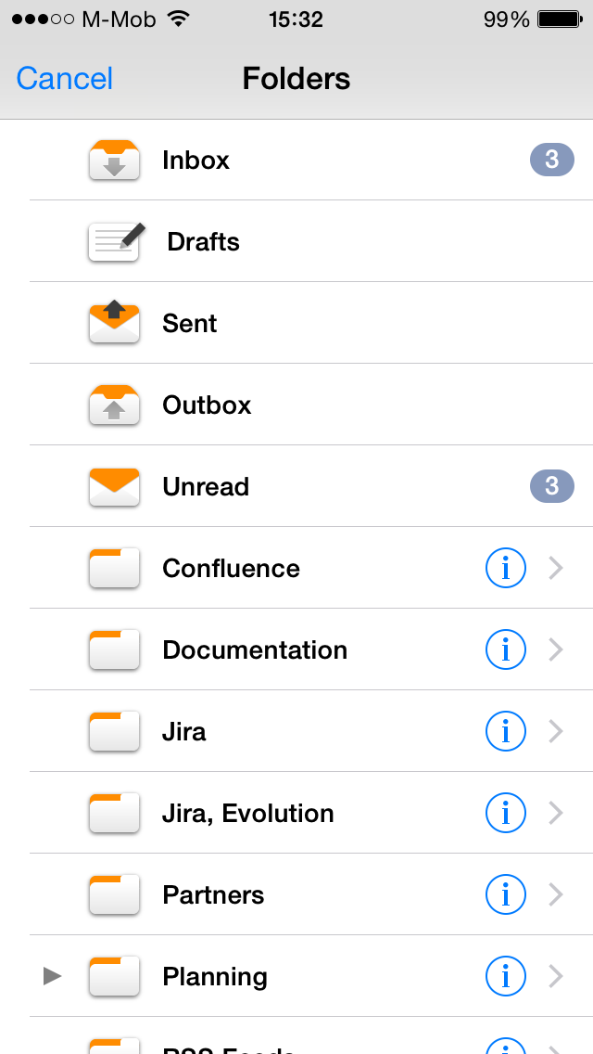

Tap on the folder you wish to see.

Tap the small Arrow to see sub-folders:

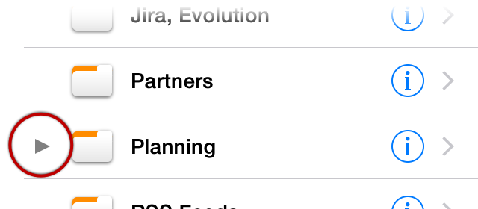

If you have folder with a lot of emails, and you already know that you are not going to look at these emails on your device, you can turn off synchronization for this folder. This will save time when synchronizing as well as preserve space on your device. To access the synchronization settings for a folder, Tap the Circle-i:

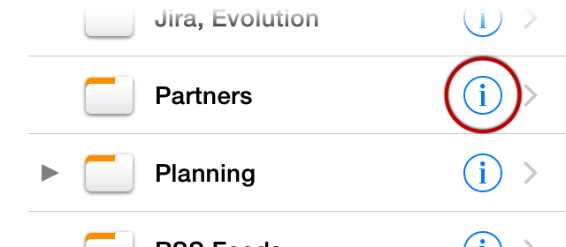

### Sort

Tap C:\AIT Data\Publishing\Word Document New Design - Soliton\DME_Quick_Guide_iOS\emailoverviewiconsort.png Sort button to sort by:

* Date.
* Sender.
* Subject.
* Flagged. Emails you have marked with a flag.
* Priority. Emails marked as important by the sender.

### Email details

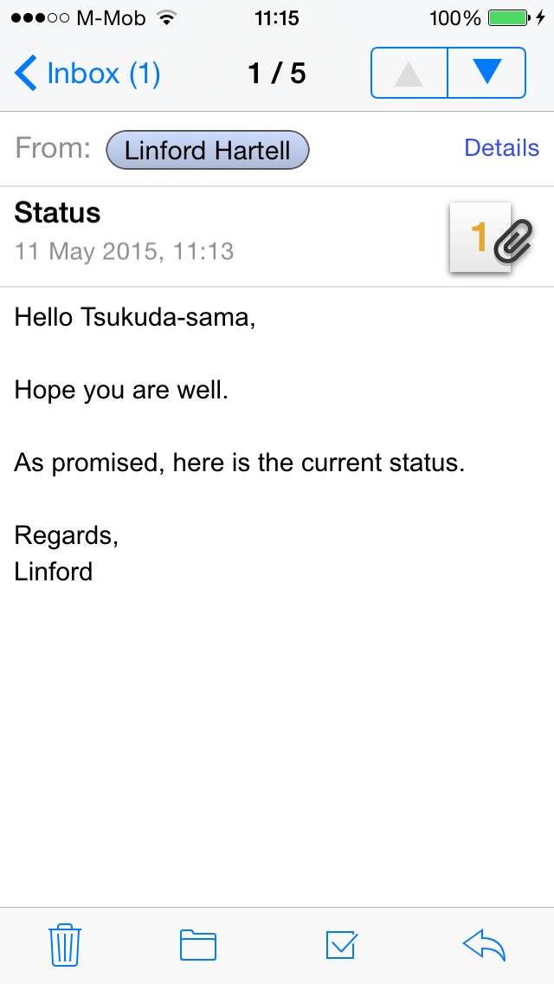

Tap  attachment icon to see attachments

Tap C:\AIT Data\Publishing\Word Document New Design - Soliton\DME_Quick_Guide_iOS\emaildetailiconnamebubble.png name bubble to choose between:

* Adding the person to your contacts.
* Searching global company address book.
* Calling the person on the phone (if the person is already in your contacts, and have a phone number).

The bottom menu contains four buttons:

C:\AIT Data\Publishing\Word Document New Design - Soliton\DME_Quick_Guide_iOS\emaildetailicondelete.png Delete the email.

C:\AIT Data\Publishing\Word Document New Design - Soliton\DME_Quick_Guide_iOS\emaildetailiconfolders.png Move the email to another folder.0

C:\AIT Data\Publishing\Word Document New Design - Soliton\DME_Quick_Guide_iOS\emaildetailiconmark.png Mark the email as read or unread, or set a Flag on the email.

C:\AIT Data\Publishing\Word Document New Design - Soliton\DME_Quick_Guide_iOS\emaildetailiconreply.png Reply or Forward the email, or create a Meeting from the email.

## Calendar

The calendar has 4 different views:

C:\AIT Data\Publishing\Word Document New Design - Soliton\DME_Quick_Guide_iOS\calendarviewmonth.png Month. Shows a month overview, and the appointments on the day selected.

C:\AIT Data\Publishing\Word Document New Design - Soliton\DME_Quick_Guide_iOS\calendarviewday.png Day. Shows a timeline of one day.

C:\AIT Data\Publishing\Word Document New Design - Soliton\DME_Quick_Guide_iOS\calendarviewlist.png List. Shows a list of upcoming appointments.

Week. Is shown when the device is in landscape mode. Shows timeline of a whole week.

### Meeting invitations

If the List view has a badge with a number, it mean you have meeting invitations that you haven't responded to. Tap C:\AIT Data\Publishing\Word Document New Design - Soliton\DME_Quick_Guide_iOS\calendarviewlist.pngList view to see the invitation at the top of the list.

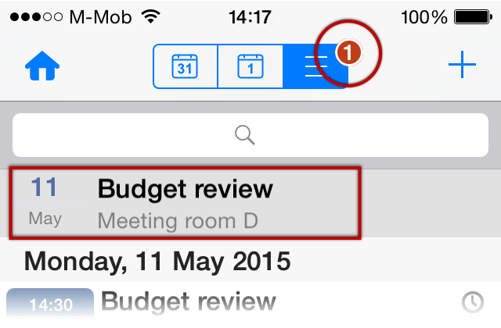

Tap the invitation to see details and respond to it (Accept, Decline, Delegate, or Tentatively accept).

Meeting invitations will also be shown as an email in your email Inbox, and you can respond to them directly from there.

### New event

To create a new event (a meeting or appointment), tap the Plus icon:

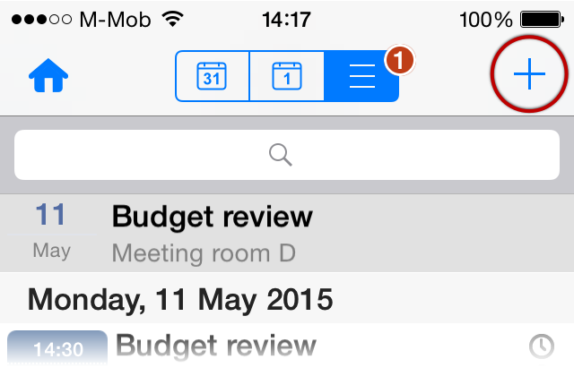

After adding Participants, Rooms, and/or Resources, a button appears that can check whether these are available at the time specified:

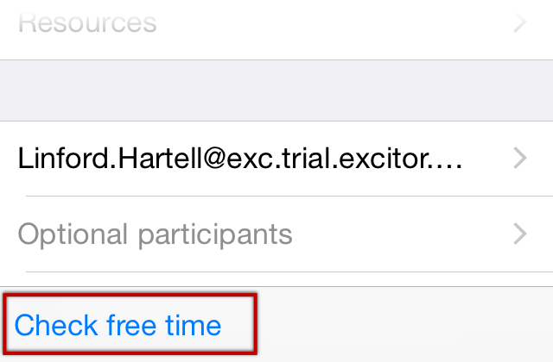

Note that you might not be able to use Rooms and Resources, depending on settings by your system administrator.

Other options include:

* Make the event recurring (tap Repeats).
* Set an Alarm
* Mark the event as Private. Private means that other can only see that you are busy, but not the subject and details.

Tap Send will send invitations to all participants and add the meeting to your calendar. If there are no other participants, the button is called Save instead.

## Contacts

If Contacts sync. is enabled (Tools (the Gear icon) > Settings > Contacts), the contacts in DME will be the same as your local address book from Outlook/Lotus Notes. Whenever a contact is added, edited, or deleted in one place, it is changed everywhere.

It is also possible to synchronize the Contacts with the local Contact app on your device. For more information, please see the complete DME App User Guide <https://resources.excitor.com/docs/dme-app-user-guide-apple-ios>.

When viewing a Contact, you have shortcuts to several actions:

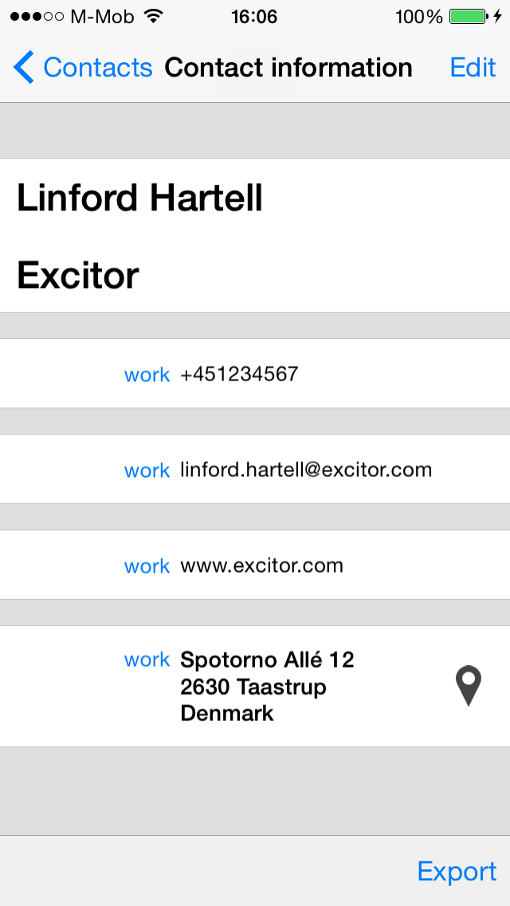

* Tap a Phone number to make a Call, or send a SMS/MMS.
* Tap an Email address to send a new Email or book a Meeting.
* Tap a Webpage to open that page.
* Tap an Address to view it on a map.

## AppBox

DME AppBox is best described as a secure corporate app store. Through AppBox, your company can provide you secure access to internal HTML5 apps, internal websites, and internal files.

Tap on an icon on the AppBox launchpad to open it:

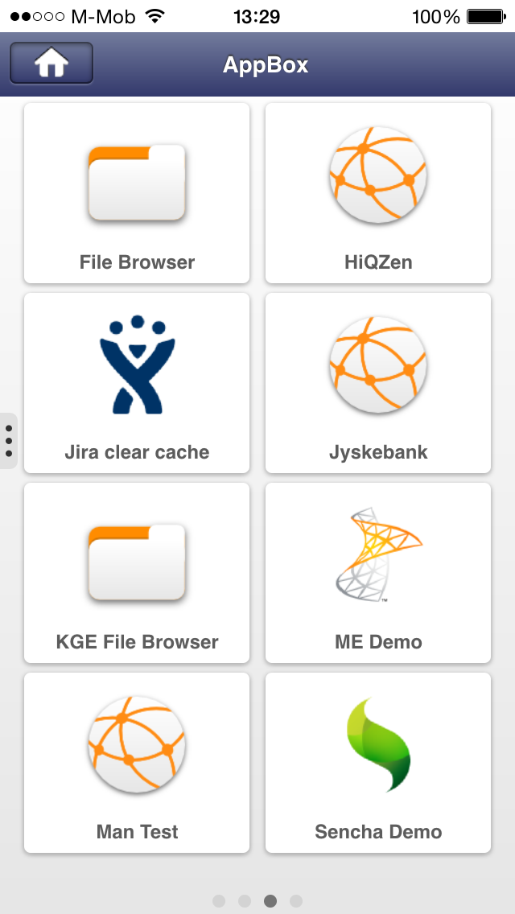

If your system administrator has set it up, you can have access to the File Browser app.

With this app, you can access files on your internal network.

You can also use it to open files that has been saved from DME or other AppBox apps. If you save an email attachment in DME, you can find in the File Browser in the folder Application > Attachments (saved).

For more information on AppBox and the File Browser, please see the complete DME App User Guide <https://resources.excitor.com/docs/dme-app-user-guide-apple-ios>.

# More

## Signed and encrypted email

In order to send signed email, and to send and receive encrypted email, DME needs to know your Private key password. On Lotus Notes this is your Notes ID password.

Enter it by selecting Tools (the Gear icon) > Settings > Security > Private key password.

If DME has already synchronized email before you do this, you have to tap Tools > Reset.... If you don't reset, you won't be able to read any encrypted emails received before you entered the Private key password.