Quick User Guide Secure Container - DME

DME 5.0 for Android

Document version 0.1

Published 16-06-2017

© Soliton Systems Europe N.V.

All rights reserved

**Disclaimer**

Soliton Secure Container - DME is trademark of Soliton Systems.

Microsoft SQL Server®, Microsoft Exchange, Outlook®, Windows, Windows Server® 2003/2008/2012, and Active Directory® are trademarks or registered trademarks of the Microsoft Corporation in the United States and other countries.

Lotus Notes® and Domino® are trademarks or registered trademarks of IBM Corporation, registered in the U.S. and other countries.

Android™ is a trademark of Google Inc.

All other trademarks are property of their respective owners.

Soliton Secure Container - DME is in part developed and sold under license from Good Technology.

Contents

[Installing Soliton Secure Container - DME 5](#_Toc485303798)

[Getting started 6](#_Toc485303799)

[Log in screen 6](#_Toc485303800)

[Server path screen 7](#_Toc485303801)

[Welcome screen 8](#_Toc485303802)

[Phone number 8](#_Toc485303803)

[Set unlock pattern 8](#_Toc485303804)

[Set unlock fingerprint 9](#_Toc485303805)

[Using DME 11](#_Toc485303806)

[Main view 11](#_Toc485303807)

[Email 12](#_Toc485303808)

[Send email 13](#_Toc485303809)

[Email overview 16](#_Toc485303810)

[Folders 18](#_Toc485303811)

[Email details 19](#_Toc485303812)

[Calendar view 19](#_Toc485303813)

[Meeting invitations 21](#_Toc485303814)

[New event 22](#_Toc485303815)

[Contacts view 24](#_Toc485303816)

[AppBox 25](#_Toc485303817)

[More 27](#_Toc485303818)

[Signed and encrypted email 27](#_Toc485303819)

[Disclosure 29](#_Toc485303820)

[Addresses 30](#_Toc485303821)

# Installing Soliton Secure Container - DME

This Quick Guide describes the installation of Soliton Secure Container - DME. If your company's Administrator provides instructions different from the instructions described in this manual, please follow these instructions.

1. Open the Play Store on your Android device.
2. Search for DME. The logo of the Soliton Secure Container – DME looks as follows:



1. Tap the Install button
2. A message with the text **Allow** this application to: is shown. Tap **Install** to accept the permission settings.
3. When the application download is complete, tap **Open** to launch the Soliton Secure Container - DME, or **Done** if you want to launch the application later.

# Getting started

## Log in screen

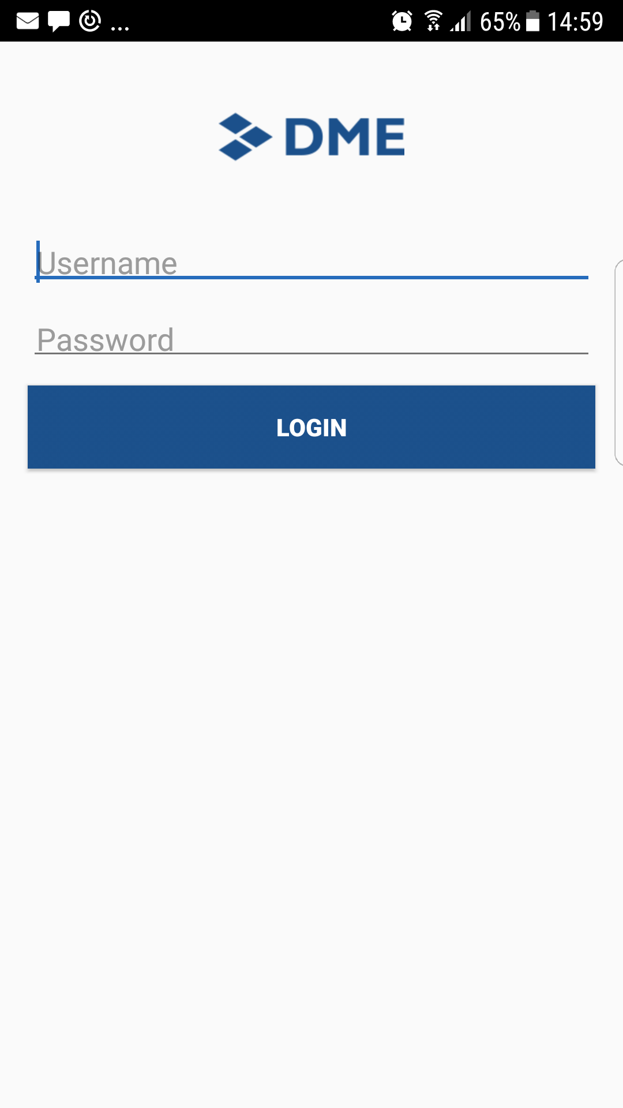

1. When starting Soliton Secure Container - DME, it will ask for your Username and Password.  
   Use the same Username and Password for logging in to your desktop computer.

If you are a Lotus Notes user, use your internet password (same as your Notes Webmail password).

In case you need support, please ask your company's System Administrator for help.

1. Tap Login.

## Server path screen

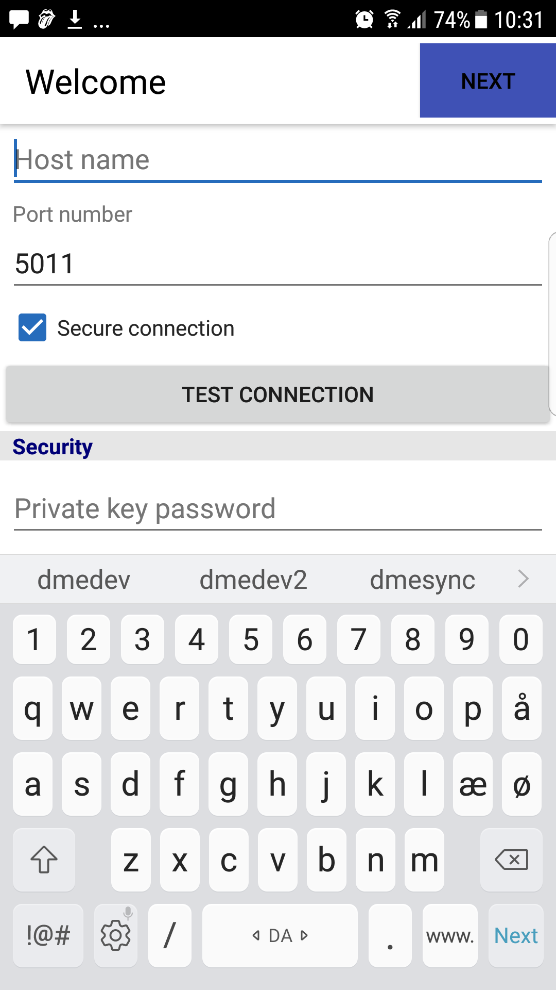

Soliton Secure Container - DME will ask for information about the server path, in particular for the Host name.

This Host name can be provided by the company's System Administrator (it usually has the form dme.yourcompany.com).

1. Enter the Host name.
2. Tap Test connection to make sure it connects to the server and the host name is entered correctly.
3. Tap Next.

## Welcome screen

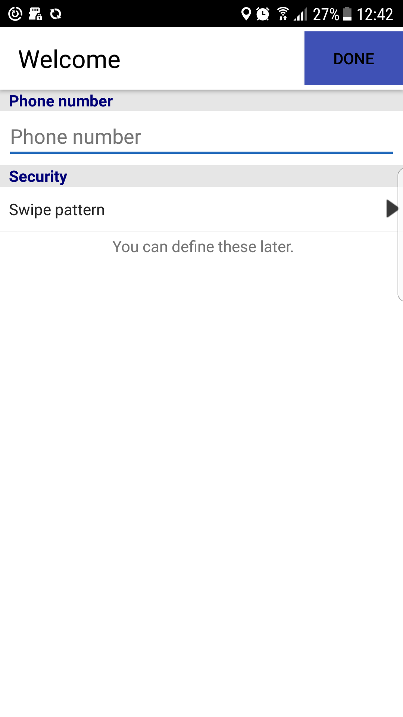

### *Phone number*

On this screen, you have the option of entering your phone number (without international calling code). This is optional, but can be of help to your System Administrator.

### *Set unlock pattern*

This provides the option of setting an Unlock pattern, which is a swipe code that can be used instead of having to type Username and Password.

1. Tap Set unlock pattern.
2. Define a pattern by moving your finger across the circles on the screen. The pattern must consist of at least 4 connected circles (connected either horizontal, vertical, or diagonal).

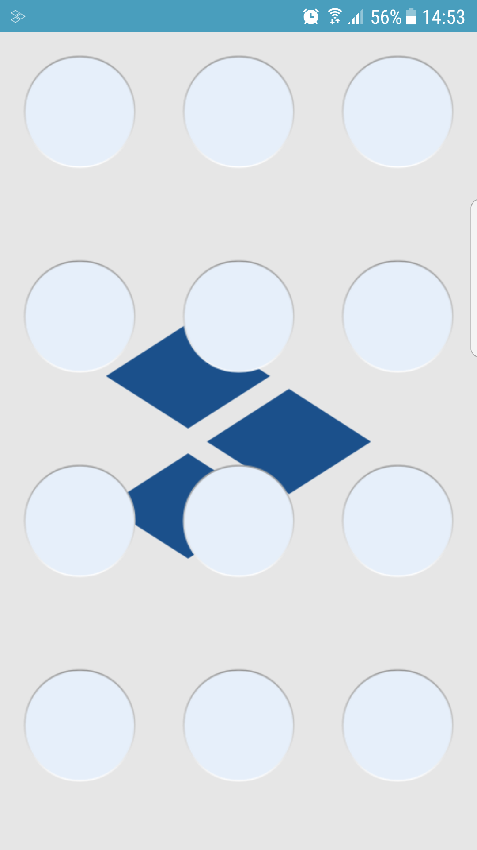

1. Please repeat the same pattern once more.

### *Set unlock fingerprint*

This provides the option of unlocking with fingerprint, instead of having to type Username and Password.

It is always possible to set the unlock option at a later stage: on the Desktop, tap MORE (the three dots) > Tools > Unlock.

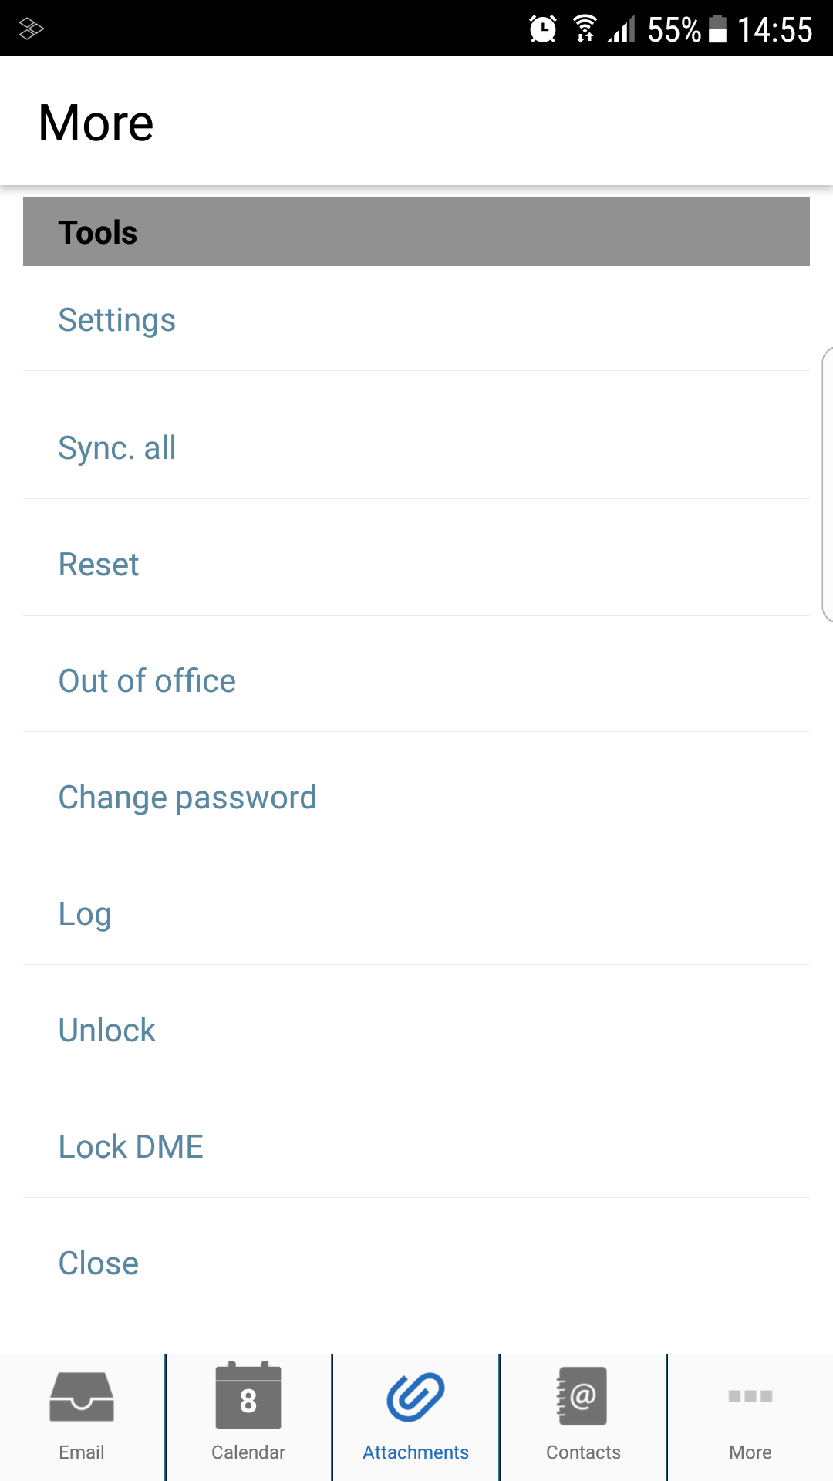

# Using DME

Soliton Secure Container – DME is now installed and it will synchronize Email, Calendar, Contacts, etc.

## Main view

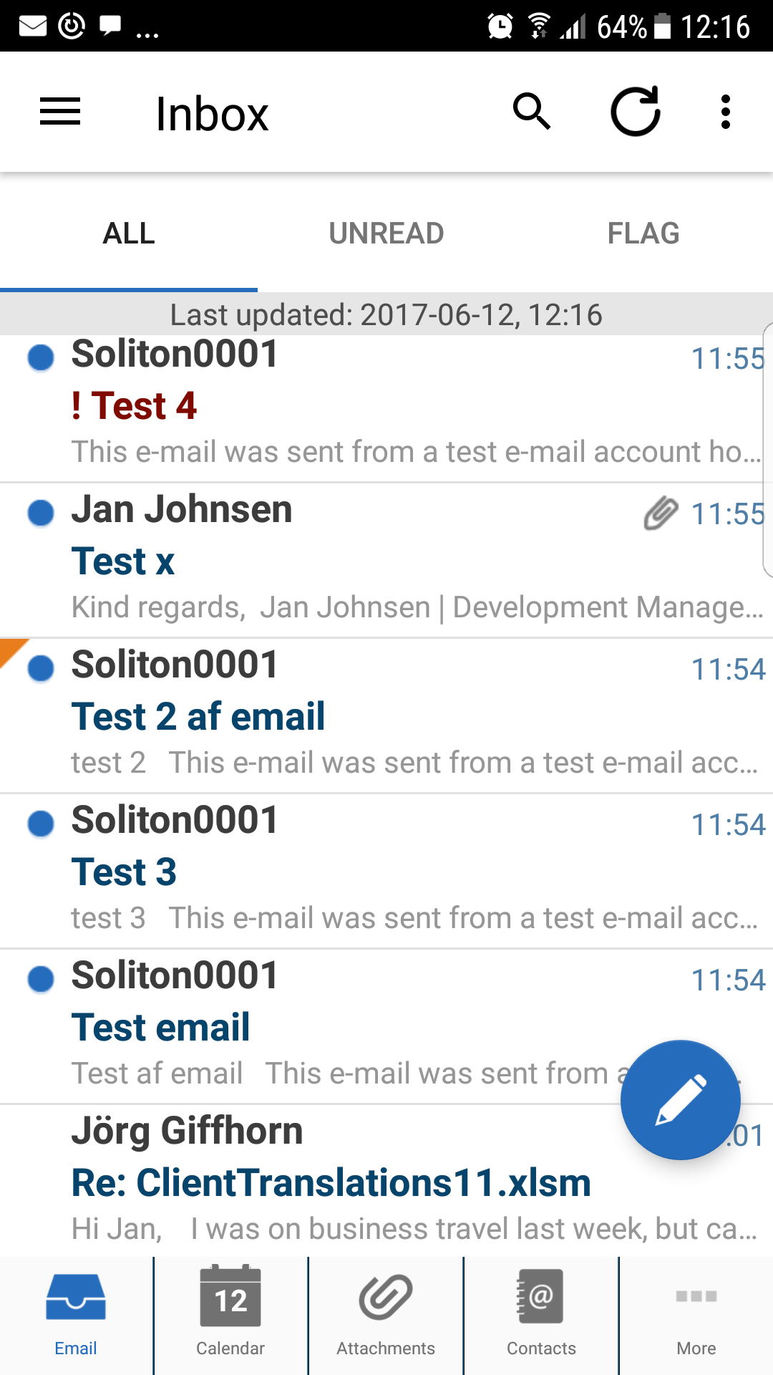

The Main view shows the most used features in the TAB bar at the bottom. Default view is the EMAIL view.

**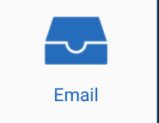** Email - Access to the corporate email.

**** Calendar - Access to the corporate calendar. Please see below.

**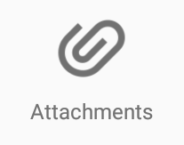** Attachments - Contains a view of all attachments from emails, calendar event, and to-dos on the device. It is possible to choose to download attachments to make sure they are available offline.

**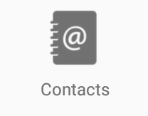** Contacts - Access to the corporate contacts. Please see below.

To-do - The list of your to-dos. This allows to filter the list to show *Incomplete to-do’s only* (standard view) or *All to-do’s*.

AppBox - Opens the AppBox Launchpad. Please see below.

## Email

To access email, tap the  EMAIL icon in the bottom TAB bar.

If you tap the **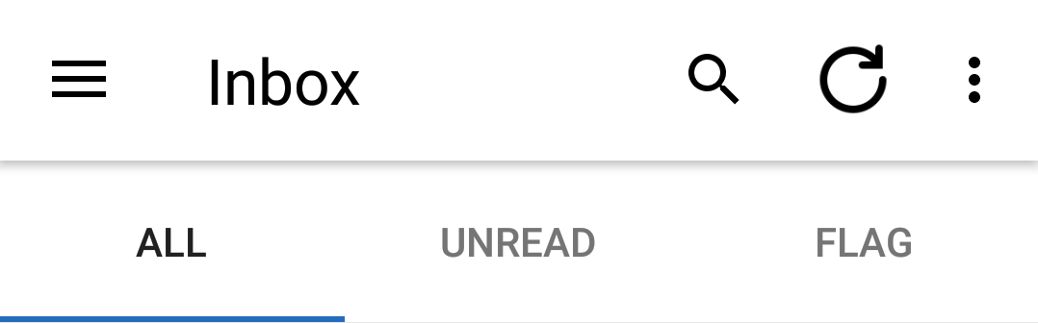**UNREAD Tab, only unread emails will appear.

If you tap the **** FLAG Tab, only flagged emails are shown.

### *Send email*

Tap the new email 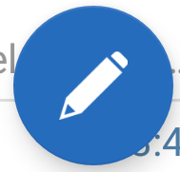 icon to begin a new email:

When you start typing To, Cc, or Bcc, Soliton Secure Container - DME will show a list of matches from the local contacts and from recently used email addresses. One can also search the local contacts on the device, or the contacts in the company directory (called Global Address Book).

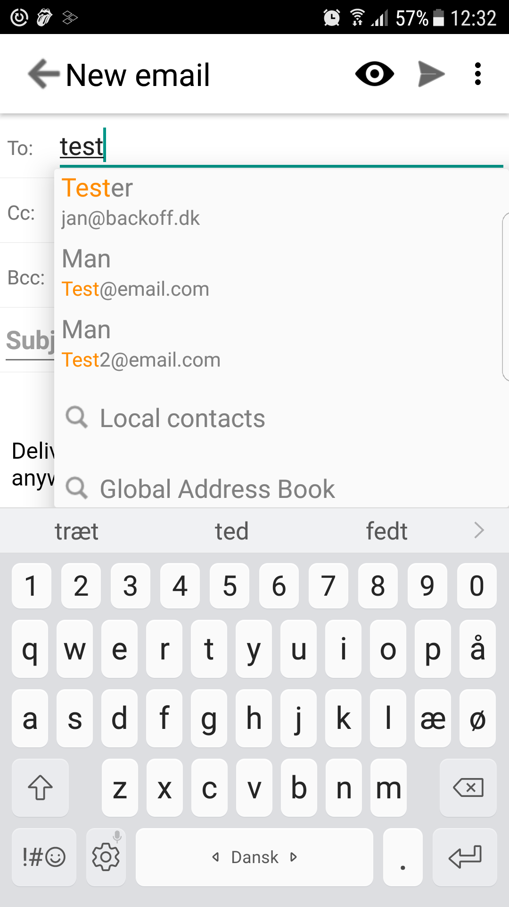

Use the eye  to

* Set message options (importance and security options)

Use the menu to  in top bar right to.

* Save as draft
* Add and manage attachments

If you tap Cancel, you also have the option of saving the email as a draft. Tap Yes and the mail is saved to the Draft folder.

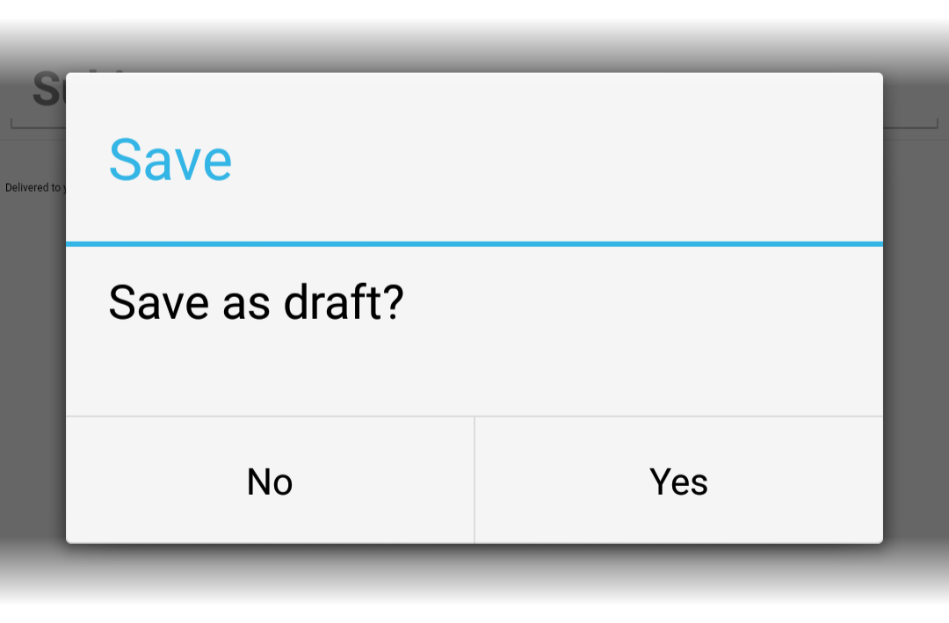

### *Email overview*

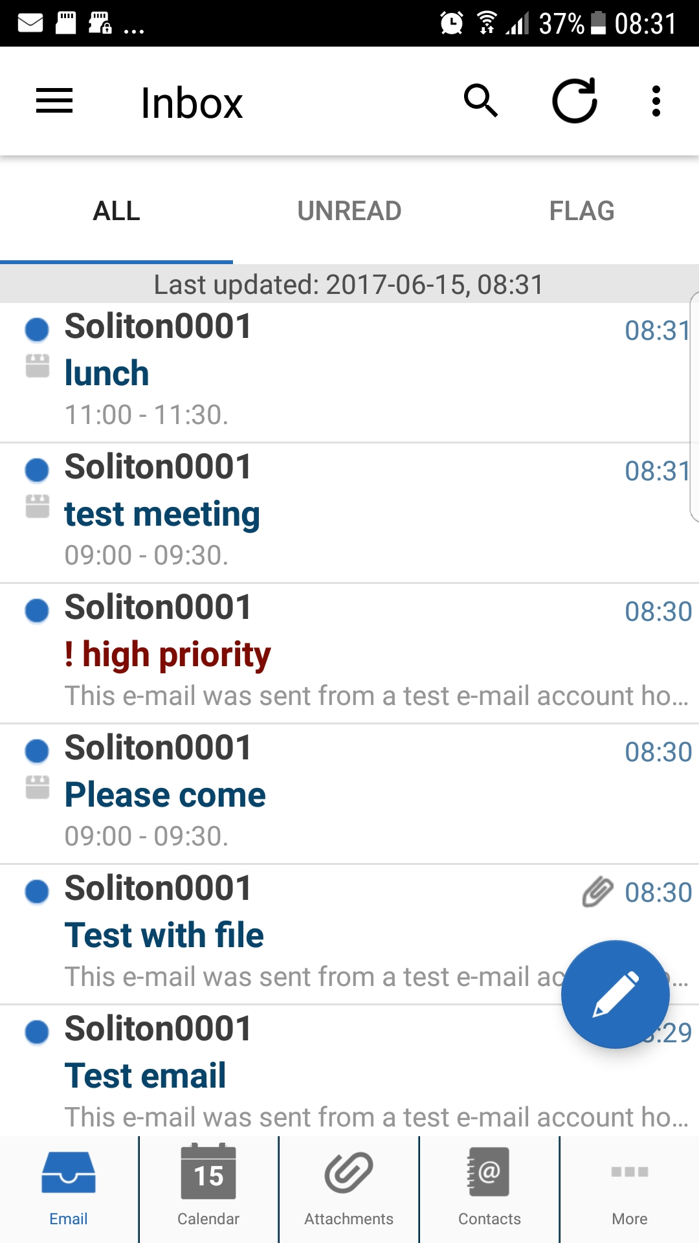

Tap on an email to view the email.

The emails can have different icons:

The email is Unread.

C:\AIT Data\Publishing\Word Document New Design - Soliton\DME_Quick_Guide_Android\emailoverviewiconattachment.png The email has Attachments.

You have Flagged this email.

C:\AIT Data\Publishing\Word Document New Design - Soliton\DME_Quick_Guide_Android\emailoverviewiconreplied.png You have Replied to this email.

C:\AIT Data\Publishing\Word Document New Design - Soliton\DME_Quick_Guide_Android\emailoverviewiconforwarded.png You have Forwarded this email.

C:\AIT Data\Publishing\Word Document New Design - Soliton\DME_Quick_Guide_Android\emailoverviewiconimportant.pngThe sender has marked this email as Important.

C:\AIT Data\Publishing\Word Document New Design - Soliton\DME_Quick_Guide_Android\emailoverviewiconinvitation.png This is a Meeting invitation.

Besides the Menu, the top bar contains a more option (the three points)  that allows the user to sort or edit emails.

**Sort:** Allows user to sort emails for

**Edit:** Allows user to perform multiple emails. Selected emails can:

* Delete them.
* Move them to another folder.
* Mark them as Unread.
* Mark them with Flags.

### *Folders*

Tap **** Three horizontal bars to the left, or perform a slide in from left side to see the list of folders:

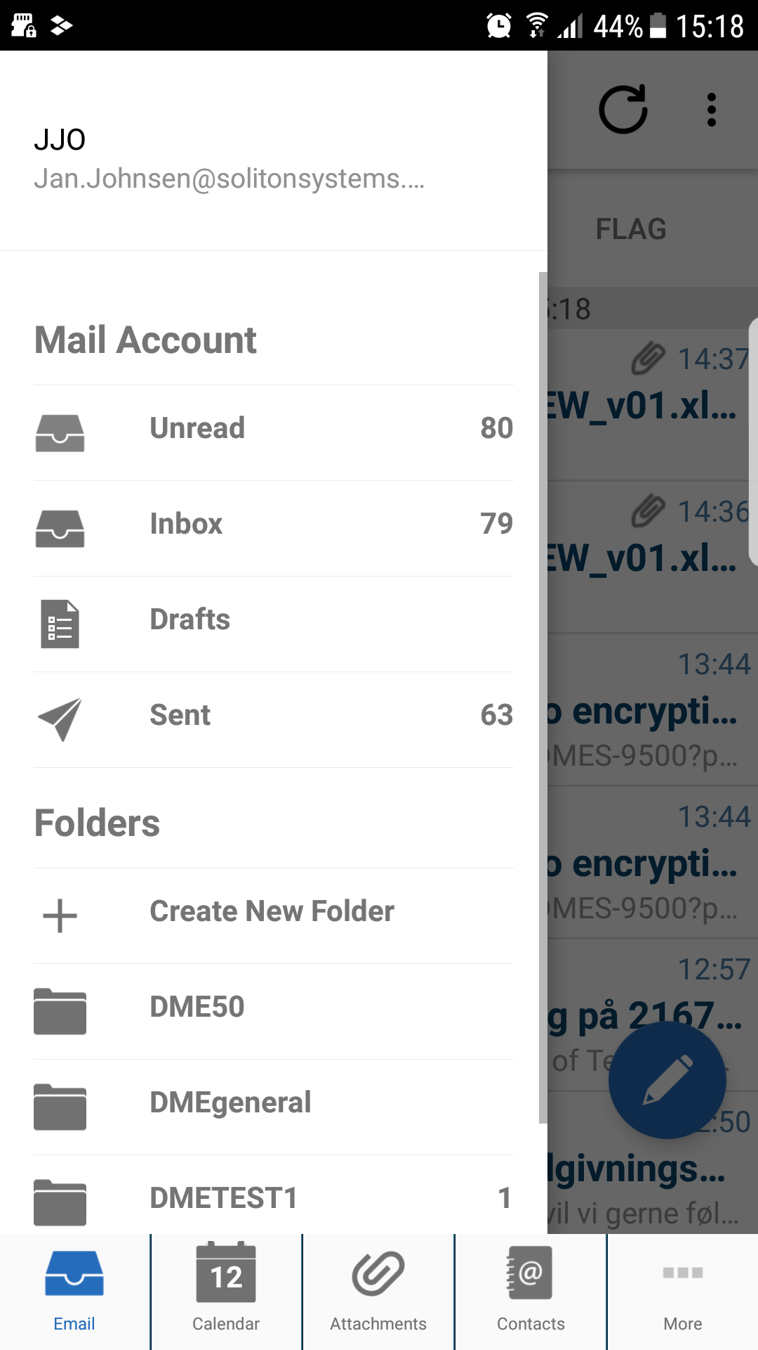

Tap on the folder you wish to see.

If a folder is empty, it might be because the folder contents are not synchronized to the device.

### *Email details*

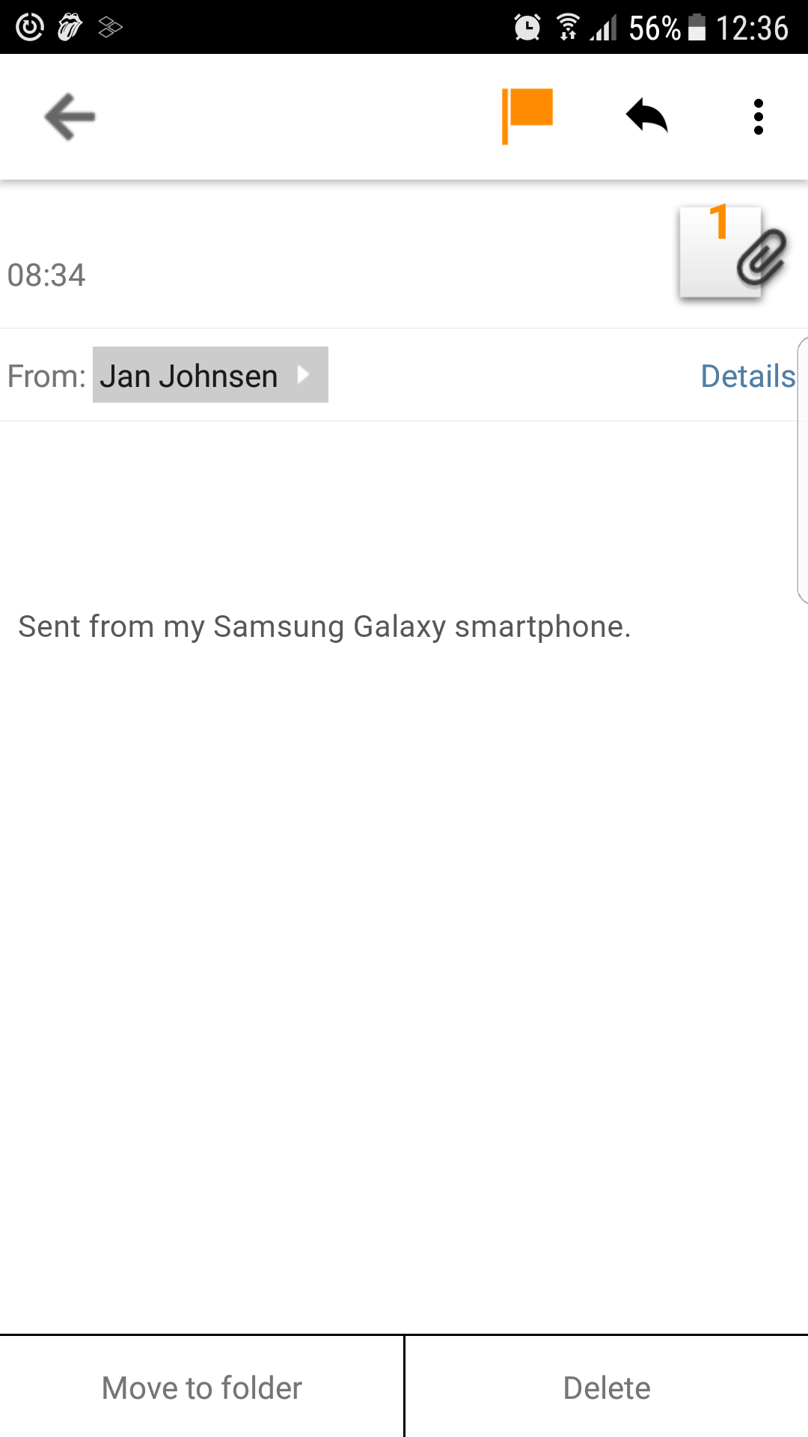

Tap attachment icon to see attachments

Tap the **FLAG** icon to toggle flag status.

Tap name bubble to add person to contacts.

The bottom menu contains two buttons:

Delete the email.

Move the email to another folder.

The top bar contains 4 options.

🡨 Back – to email view

Flag – Toggle flagged option on email

C:\AIT Data\Publishing\Word Document New Design - Soliton\DME_Quick_Guide_Android\emaildetailiconreply.png Reply, Reply to All or Forward the email.

C:\AIT Data\Publishing\Word Document New Design - Soliton\DME_Quick_Guide_Android\emaildetailiconmenu.png Add to contacts, or see email Details.

## Calendar view

The calendar has a split view:

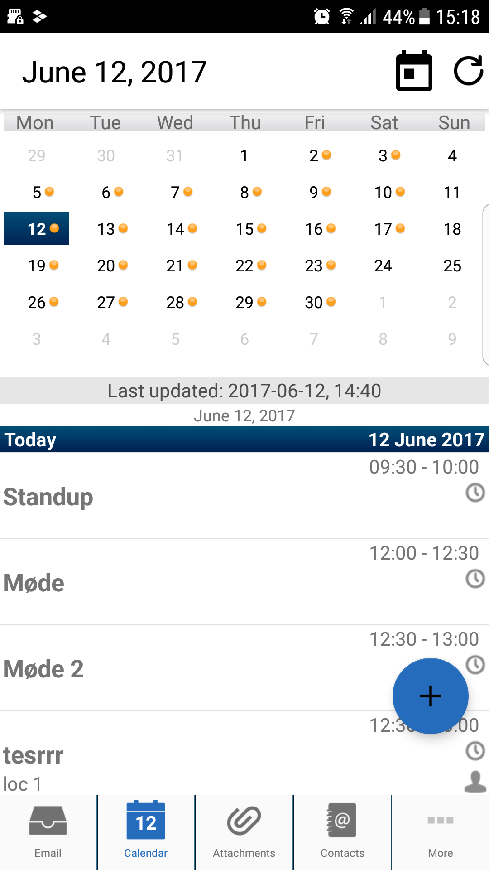

 Month. Shows a month overview, and the appointments on the day selected.

Days. Shows a timeline of a days in scrolled view

The top menu shows the present day, and the Date in top bar will make the calendar view jump back to present day.

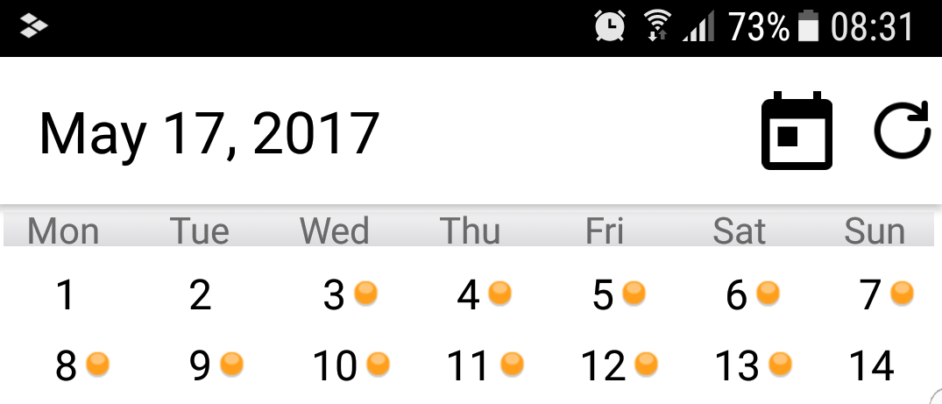

The Sync icon enables a forced synchronization to the backend exchange.

### *Meeting invitations*

Meeting invitations are received in your email Inbox, and you can respond to them directly from there (Accept, Decline, or Tentatively accept):

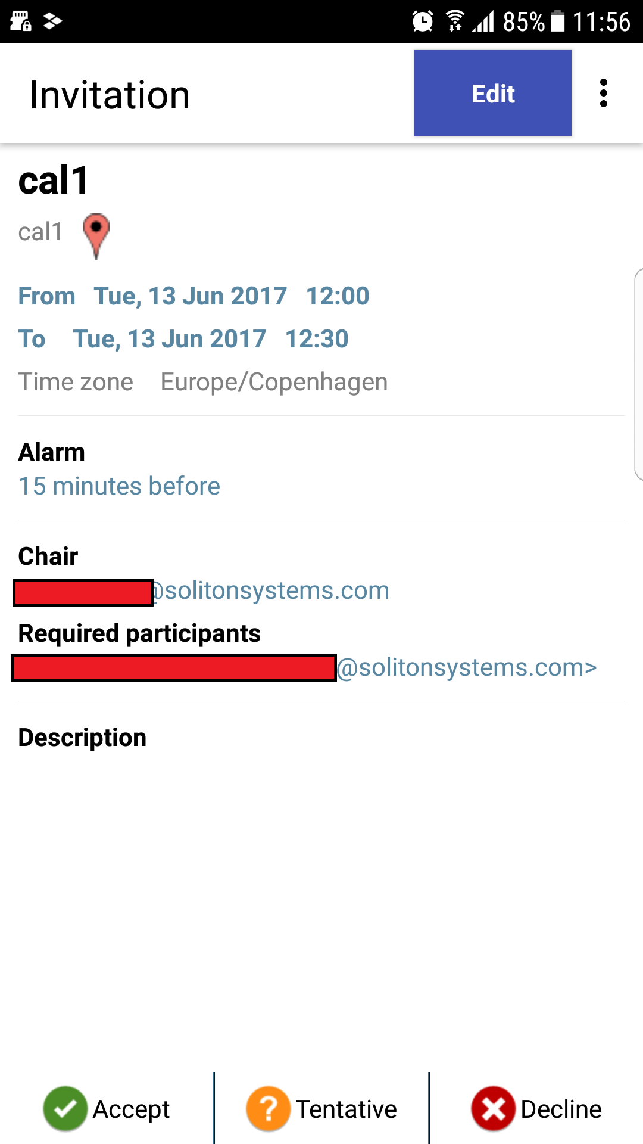

### *New event*

To create a new event (a meeting or appointment), tap the Plus icon:



Using the menu, you can check whether the Participants are free at the time you have suggested:

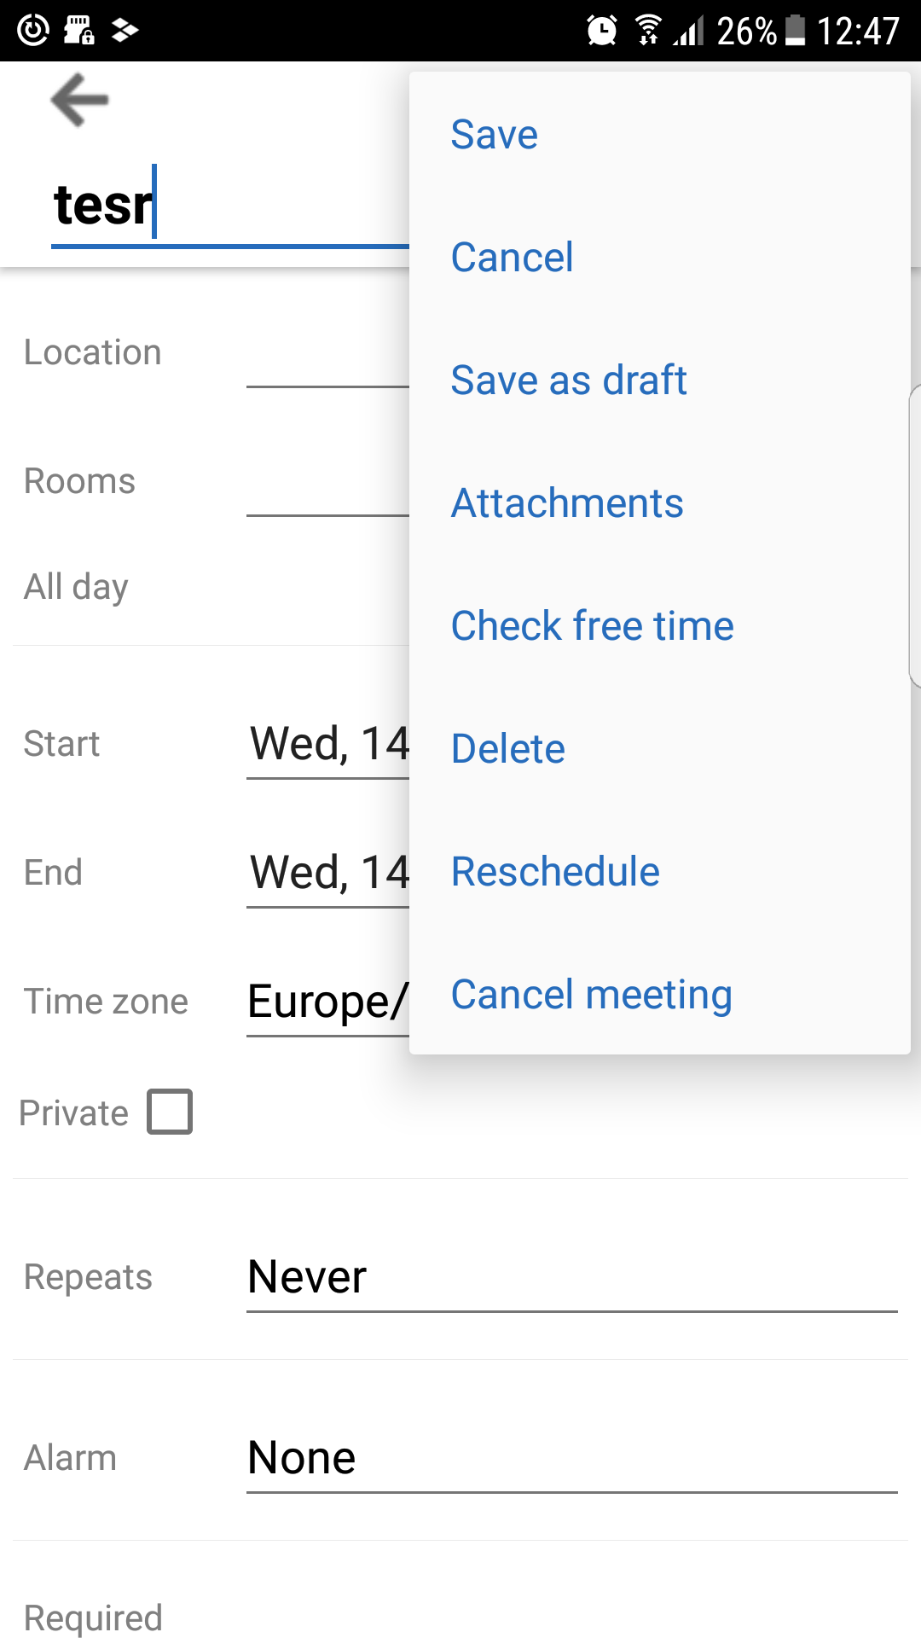

Other options include:

* Make the event recurring (tap Repeats).
* Set an Alarm
* Mark the event as Private. Private means that other can only see that you are busy, but not the subject and details.

Tap Save will send invitations to all participants and add the meeting to your calendar.

Added options from … access

* Add attachments to the meeting invitation
* **Cancel** meeting
* **Reschedule** meeting
* **Check** free time
* **Delete** meeting

## Contacts view

If Contacts sync. is enabled, the contacts in Soliton Secure Container - DME will be the same as your local address book from Outlook/Lotus Notes. Whenever a contact is added, edited, or deleted in one place, it is changed everywhere.

It is also possible to synchronize the Contacts with the local Contact app on your device. For more information, please see the complete ***Soliton Secure Container*** - DME App User Guide

When viewing a Contact, you have shortcuts to several actions:

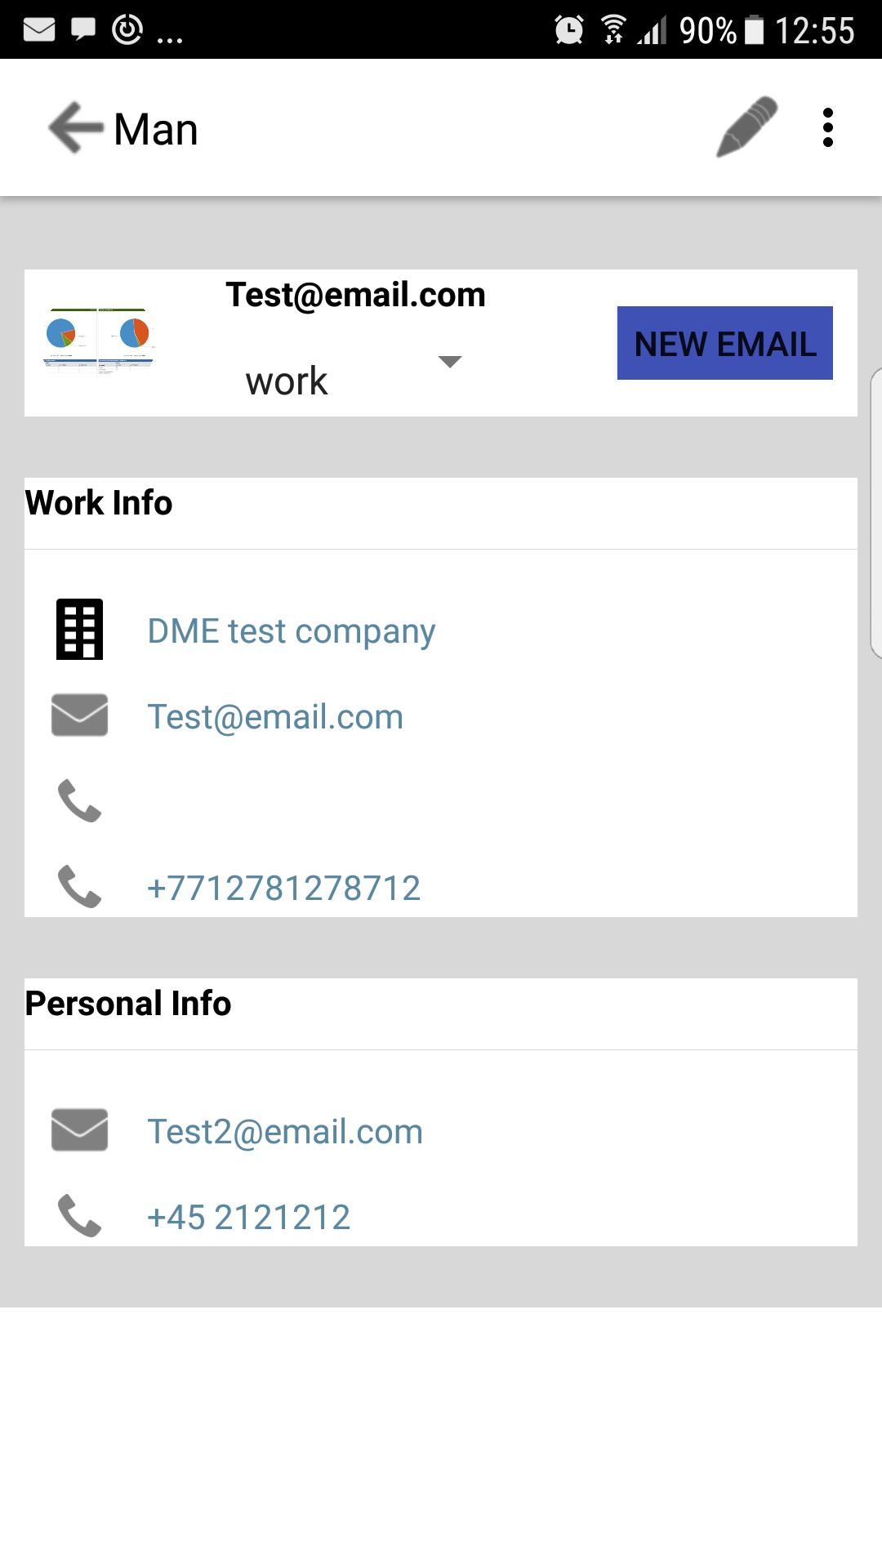

* Tap a Phone number to make a Call to the contact.
* Tap an Email address to send a new Email or book a Meeting.
* Tap an Address to view it on a map.

## AppBox

The Soliton Secure Container - DME AppBox is best described as a secure corporate app store. Through the AppBox, your company can provide secure access to internal HTML5 apps, internal websites, and internal files.

Tap on **More** icon and select **APPBOX** to access appbox.

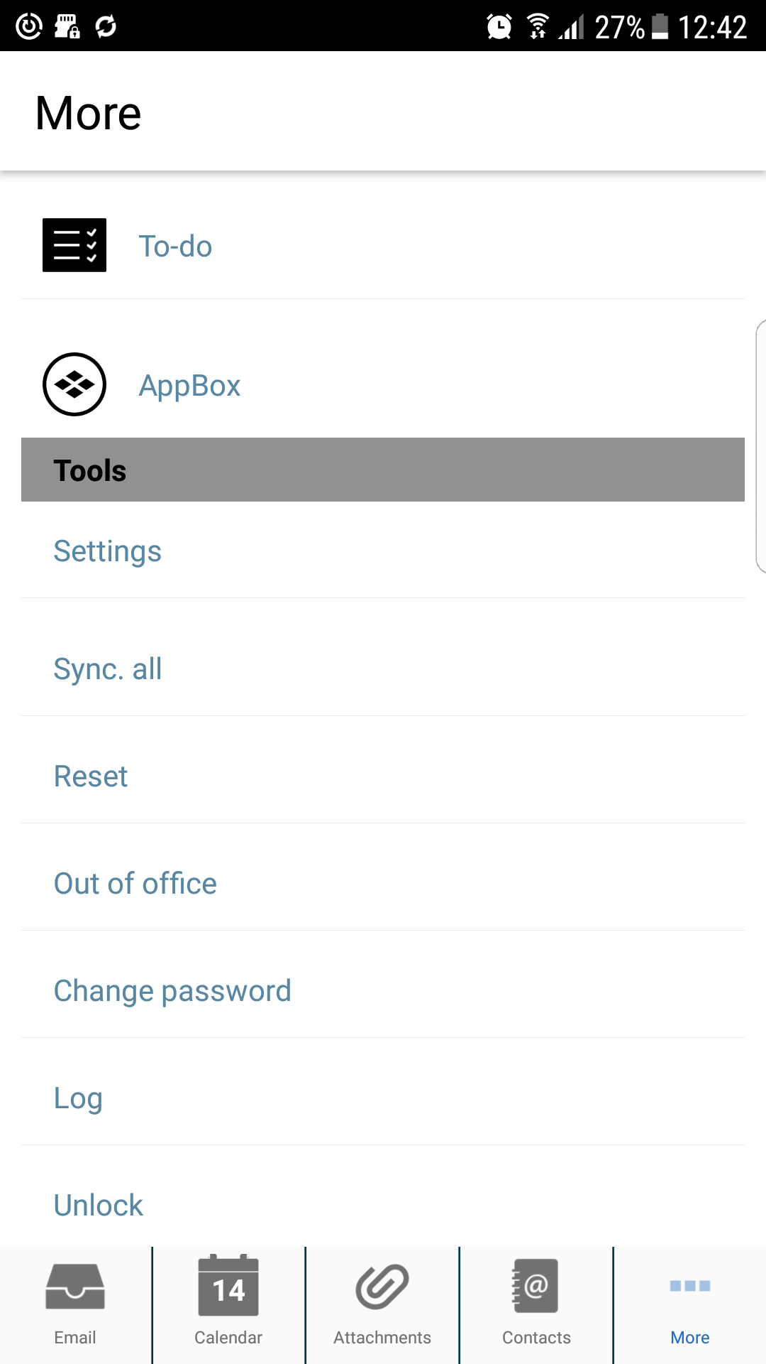

When set up by the system administrator, access to the File Browser app is available.

With this app, access to files on the internal network is provided.

It also allows to open files that have been saved from Soliton Secure Container - DME or other AppBox apps. If an email attachment is saved in Soliton Secure Container - DME, it is stored in the Attachments Tab bar

For more information on AppBox and the File Browser, please see the complete ***Soliton Secure Container*** - DME App User Guide.

# More

## Signed and encrypted email

In order to send an signed email, and to send and receive encrypted email, Soliton Secure Container - DME requires the Private key password. On Lotus Notes this is the same as the Notes ID password.

Enter the private key password by selecting **More** > Tools > Settings > Security > Private key password.

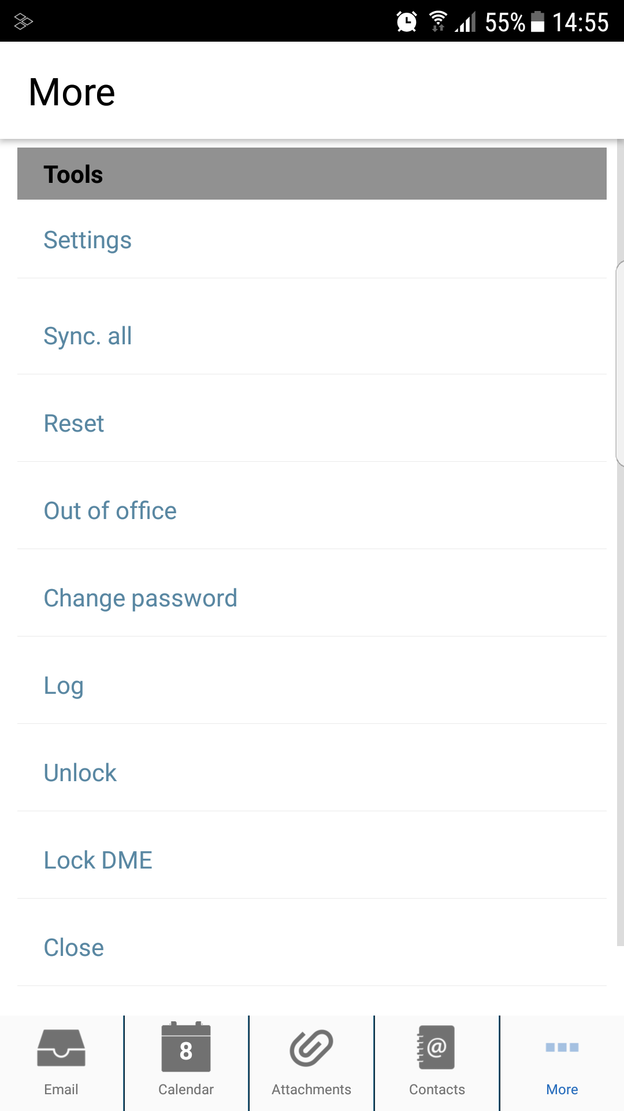

If the Soliton Secure Container - DME has already synchronized email before entering the private key password, please tap Tools > Reset.... Without the reset, you will not be able to read any encrypted emails received before you entered the Private key password.

# Disclosure

All rights reserved. You shall not copy, duplicate, reprint, reprocess or perform any other act equivalent to those acts by any means without the permission of Soliton Systems K.K.

All information herein was carefully gathered and examined. However, we cannot be held responsible for eventual mistakes or incompleteness. All information, items and data in this user manual are subject to change without any notice. We especially pay the utmost attention to provide correct information, items and data in this manual. However, our company assumes no responsibility for any lost properties, accidents and damages.

# Addresses

|  |  |
| --- | --- |
| Japan office (Corp. Headquarters)  Soliton Systems K.K.  2-4-3-Shinjuku, Shinjuku – ku  Tokyo 160-0022  Japan | T: +81-3-5360-3801  E: wwsales@list.soliton.co.jp |
| EMEA office Soliton Systems Europe N.V.  Gustav Mahlerplein 2  1082 MA Amsterdam  The Netherlands | T: +31-20-301-2166  E: emea@solitonsystems.com |
| US office  Soliton Systems Inc.  2635 North First Street, suite 213  San Jose CA95134  USA | T: +1-408-434-1923  E: sales@solitonsys.com |
| US office  Soliton Cyber & Analytics, Inc.  3900 Kilroy Airport Way, Suite 280  Long Beach, CA 90806  USA | T: +1-714-243-6121  E: sales@solitonca.com |
| China office  Soliton Network Systems Co. Ltd.  Room 410, Chanfa Building,  No 128 Weihai Road  Shanghai 200003  China | E: zhu@soliton.com.cn |
| APAC office  Soliton Systems Singapore Pte. Ltd.  High Street Centre  1 North Bridge Road  #08-08  Singapore 179094 | T: +65-9062-0710  E: apac@solitonsystems.com |
| Soliton Development Centre Europe  Soliton Systems Development Center Europe A/S  Spotorno Allé 12  2630 Taastrup  Denmark | T: +45 7021 6800  E: mail@solitonsystems.com |