# Welcome to Excitor DME!

DME helps you stay connected with your corporate e-mail, calendar, and contacts any time. What you see on your Android device is what you have on your desktop or laptop computer at the office.

DME completely secures the business data on your device – so if you lose it or it is stolen, you can be certain that nobody can get to your data.

This guide to DME for Android applies to all supported Android devices.

## Getting started with DME

To start using DME, you need to get the DME app from Google Play Store first.

1. Open the Google Play Store on your Android device. Search for "DME" using the search box. DME is published by Excitor.

*or*

Go directly to the DME client download page in the Google Play Store by typing <https://play.google.com/store/apps/details?id=dk.excitor.dmemail> in a browser on your device, or by following a link sent to you by your DME Administrator.

1. Tap the **Install** button.
2. A message with the text **Allow this application to:** is shown. Tap **Install** to accept the permission settings.
3. When the application download is complete, you can tap **Open** to launch DME right away, or **Done** if you want to launch DME later.

Tap the DME icon to launch DME. The first time DME is started, a setup wizard asks you some questions. This information has probably been sent to you by your DME administrator – otherwise contact him or her.

1. First you are asked if you want to enable notifications for this program. You should do this in order to receive notifications of new e-mails etc.
2. DME asks you for your user name and password. These are the same username and password that you use to log in to your network. If you are using Lotus Notes on your desktop computer, you need to enter your “Internet password”. Contact your IT department if you have problems with this.
3. DME then asks you for the *server path*. The server path has the form **dme.yourcompany.com:5011**, where **dme.yourcompany.com** is the host name of the server where DME is installed, and **:5011** is the port number.

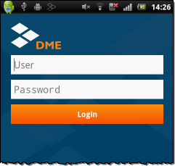 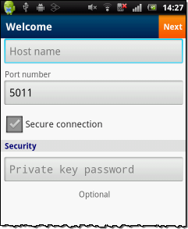

*DME Login screen DME Server path screen*

Usually you only need to enter the path – the port number is set to default **5011**, and the **Secure connection** switch inserts the **https://** part of the path for you.

1. If you are using Lotus Notes encrypted e-mail, enter your **Notes ID password** in the **Private key password** field. If you don’t do this now, you can do it later in **Tools** > **Settings**. However, if DME has already synchronized e-mail before you enter your private key password, you must tap **Tools > Reset**, andconfirm that you wish to re-import your DME data. This is to ensure that all Notes encrypted e-mails are displayed correctly on your device. If you do not **Reset** DME, you will not be able to read any Notes encrypted e-mails received before you entered your Notes ID password.

If you use S/MIME (and not Notes encryption), enter the password for your S/MIME private key in the field, and upload your private certificate using MyDME (see the full **DME for Android User Guide** (available on the Web: <http://documentation.excitor.com>).

1. Tap **Next**. DME attempts to log in. The first login takes a little longer time than what it will usually take.

DME connects to the server you specified in the **Server path** screen. If your username and password were correct, DME is initialized for first use. (*Note*: In some secure setups, the DME Administrator requires a manual verification process before you can start synchronizing.)

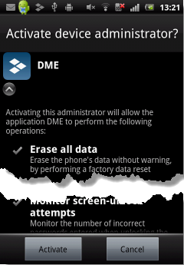If the DME administrator has set specific **security policies** for your device, you will now be prompted to make sure your device complies with these policies. You may for instance be taken to the screen on your device where you can specify a device PIN code or password, where you will be guided to set it correctly. Some security policies require that the DME system must administer your device. You must allow DME to do this in order to use DME. DME shows the following prompt, which you must accept.

By tapping **Activate**, you grant DME the right to administer your phone. Note that you cannot log into DME until you have done this.

If the login was successful, the next (and last) step of the setup wizard is shown:

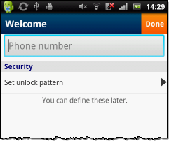

Enter your phone number (DME is not permitted to get the number automatically), and set an unlock pattern. Using an unlock pattern (*swipe* pattern) to log in is easier than entering your full network password.

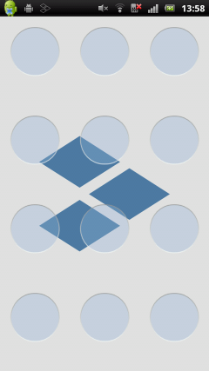Define a swipe pattern by moving your finger vertically and horizontally across any of the 12 *tiles* on the screen. Repeat. The next time you log in to DME, you can use this swipe pattern for logging in instead of your full network password.

Note that your DME administrator has set up minimum requirements for the number of tiles you must swipe to create a valid pattern. Also, if you haven’t logged in for a while, you may need to log in using your full network password (but after that, you can use the swipe pattern again).

Tap **Done** in the wizard.

DME will start *importing* your corporate e-mail, calendar, and contacts (and more) to DME on your device. Your DME administrator has set up an initial profile for you, which controls the number of e-mails and events that are imported to and kept synchronized with your device, expressed as a number of days. You can for instance get your e-mails from 20 days back, and your calendar entries from 7 days back till 100 days into the future. This is called the *sync window*.

After the initial import process is complete, you have access to your corporate data from your device, and you can start using your e-mail, calendar, contacts, and other resources synchronized by DME. You can access the different parts of DME from the DME Desktop:

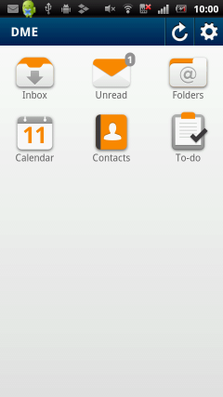 *The DME Desktop*

Note that the Desktop only shows icons for the features to which you have access. For more information, see the full **DME for Android User Guide** (available on the Web: <http://documentation.excitor.com>).

## E-mail

http://documentation.excitor.com/client/4_0/Android/icon_inbox_home.pngTap the **Inbox** icon on the Desktop to access your corporate e-mail:

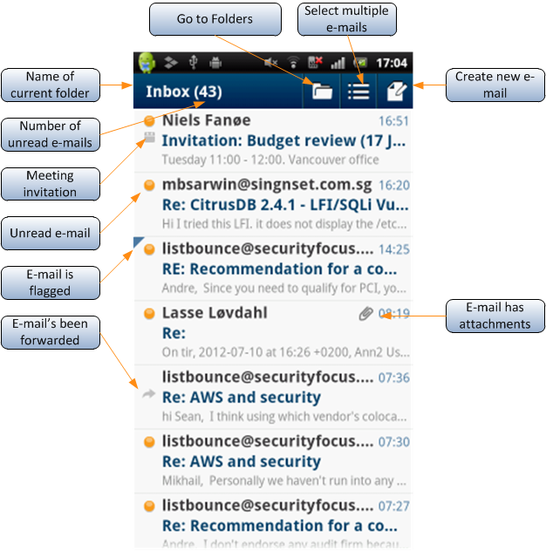Just after the name of the folder, you can see the number of unread e-mails in the folder.

The received time of the e-mails is shown as a time of day when received today, and as a day in the week for e-mails received during the past week. E-mails received before that show with the full received date.

Drag up/down, or flick to see more e-mails.

*Long-press* an e-mail in the Inbox to perform an action on the e-mail (**Reply**, **Forward**, **Mark unread**, etc.). If you want to perform an action on a number of e-mails in the Inbox, you can select them by tapping the checkbox icon to the left of each e-mail after tapping the Edit button http://documentation.excitor.com/client/4_0/Android/edit_icon.png. As an alternative to long-pressing, you can always open the DME menu by pressing the **Menu** button.

It is good practise to perform an e-mail sync after carrying out mailbox management functions, such as deleting e-mails or moving e-mails to folders. To do a manual sync, press the **Menu** button, and tap **Synchronize**. DME automatically synchronizes when you send e-mails and meeting invitations.

Each e-mail has an icon that tells you about its status.

|  |  |  |  |  |
| --- | --- | --- | --- | --- |
| Icon | Meaning | | | |
|  | An unread e-mail. The sender is displayed in a **boldface** font. | (no dot) | | An already read e-mail. |
|  | You have replied to this e-mail. |  | You have forwarded this e-mail. | |
|  | This e-mail has attachments. |  | This is a meeting invitation. | |
|  | This means that you have marked the e-mail for follow-up. | | | |

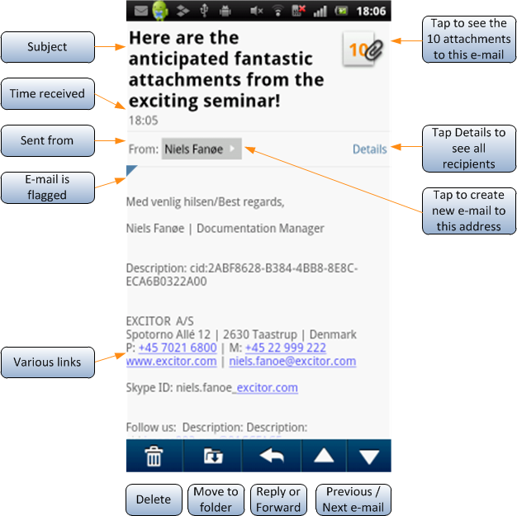Tap an e-mail to read it. You can swipe left or right to view the next or previous e-mail.

Directly from the e-mail screen you can choose to **Reply**, **Move to folder**, and **Delete**. The **Menu** button contains all the other actions available for this e-mail: **Forward**, **Move to folder**, **View details**, and **Flag**.

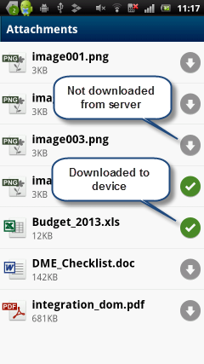In the e-mail body, you will often see underlined text – those are links. DME creates links to web addresses, e-mail addresses, and phone numbers. Clicking a web link from an e-mail opens the link in the device web browser. Clicking an e-mail address or phone number lets you decide what to do – either create an e-mail or place a call, add a new contact, or update an existing contact.

If the e-mail contains attachments, you can tap the paper clip icon next to the subject at the top to see a list of those attachments. You can open an attachment from the list. The attachment list shows which attachments are only located on the mail system server, and which have been downloaded to your device.

If the DME document viewer (licensed from Picsel) has been enabled for your DME account, your attachments will be opened in a separate viewer, inside the secure DME container.

### Composing and sending an e-mail

Tap the **Compose e-mail** icon from any mailbox http://documentation.excitor.com/client/4_0/Android/bar_icon_compose.png, or select **Create** from the DME menu.

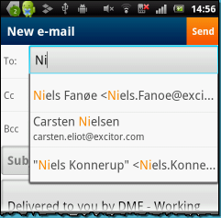 Select recipients in the **To**, **CC**, and **Bcc** fields. As you start typing, DME helps you by showing a list of known contacts (first screenshot to the left).

This list of known contacts derives from your local Contacts and from e-mail addresses you have used recently.

Tap a contact to insert it, or swipe your finger up or down the list to view the full list. If the required contact is not shown in the list, you can use the bottom two options: **Local Contacts** or **Global Address Book** to search your local or global (your company directory) contacts, respectively. DME uses the letters you have already typed as a search criterion.

When you have entered recipients, a subject, and a message, tap **Send** to dispatch the e-mail. DME starts synchronizing with the server, delivering your new message and receiving any new messages that may have arrived.

If you are interrupted, you can tap **Save as draft** to close the e-mail and save it in the Drafts folder. You can open the draft from that folder and continue working at a later time.

## Contacts

If Contact synchronization is enabled, DME will manage a copy of your local address book from Outlook or Lotus Notes on your device. Whenever a contact is added, removed, or edited on the device, the changes are synchronized with Outlook or Lotus Notes – and vice versa.

By default, the contacts are stored securely within DME, and are accessible by tapping the **Contacts** icon from the **Desktop**: http://documentation.excitor.com/client/4_0/Android/icon_contacts_home.png

Flick through the list to find the contact you need, or start typing in the **Search** field. The list of contacts will shrink as you type. Press the Back button to remove the keyboard and show the results. Delete the search text to show all contacts again.

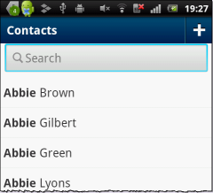 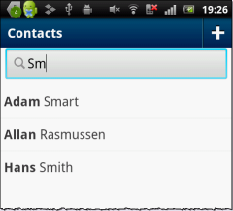

By long-pressing a contact in the contact list, you can see options to easily place a call, create an SMS or MMS message for, create an e-mail for, or book a meeting with the person in question. Tap a contact to view and edit it.

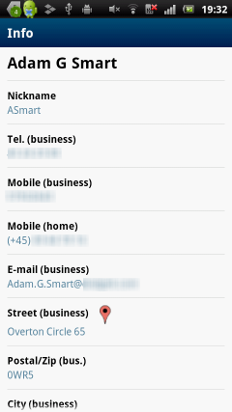You can now tap any of the fields to use the information in the field:

* Tap a Phone field to create an SMS message to the contact, or place a call to the contact.
* Tap an E-mail field to create an e-mail for the contact, or book a meeting with the contact.
* Tap a Website field to open the link in the Browser app.
* Tap an Address field to open the address locationi in Google Maps.

If you need your business contacts in the device **Contacts** (**Phonebook**) app as well, you can let DME synchronize your contacts with the local device contacts. When you do this, all your contacts are copied out into a contact group called **DME** and are kept synchronized with your contacts in DME. This way, you can use your business contacts without having to log in to DME. Please note that this synchronization option may be disabled for security reasons. For more information, see the chapter **Interaction with the device Contacts** in the full **DME for Android User Guide**.

## Calendar

DME contains a fully featured, secure Calendar. Open the calendar by tapping the **Calendar** icon on the **Desktop**: http://documentation.excitor.com/client/4_0/Android/calendaricon.png

The Calendar has four views: **Month**, **Day**, **Week**, and **List** view. These views are shown below:

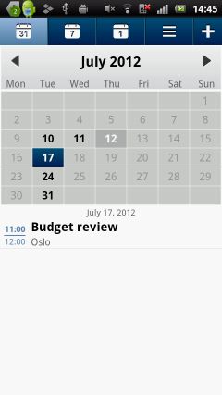 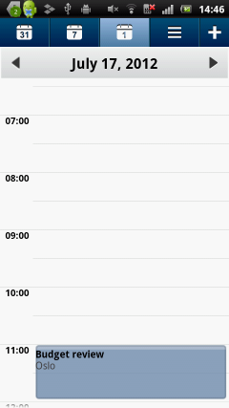 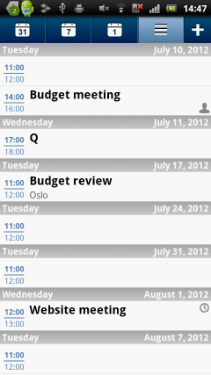 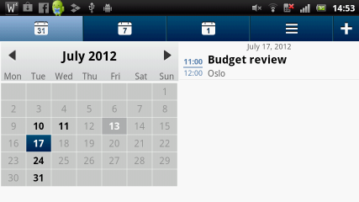

***Month*** *view,* ***Day*** *view,* ***List*** *view, and* ***Month*** *view in Landscape mode*

All views can be seen in Portrait and Landscape mode. To switch views, tap the icons in the top part of the screen.

The events shown are color-coded according to their type.

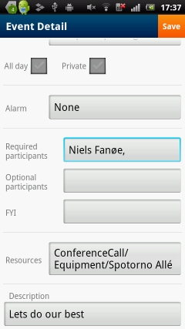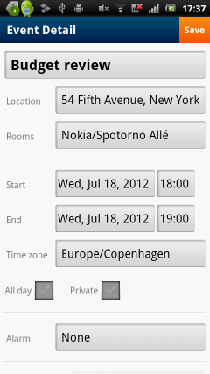To book a meeting (add an event), tap the **Add event** button (the http://documentation.excitor.com/client/4_0/Android/plus_icon.png) from the Calendar (or select **Create** in the menu).

Complete the required fields. Adding participants works in the same way as for e-mails. You can also book rooms and resources, if your system administrator has made these items available.

After selecting participants, rooms, and resources, you can tap the **Check free time** option in the DME menu to see if they are all available, and optionally select a new date or time for the meeting.

You can choose to make a meeting recurring at fixed intervals, and you can set an alarm for yourself. You can also can mark the event Private, if you don’t want other people to be able to see the contents of the event in your Outlook or Notes calendar.

When you are done, tap **Send**. Invitations are sent to all participants, and the event is added to your own calendar. If the appointment is for yourself only, the **Send** button is called **Save**.

Meeting invitations are received in the **Inbox**. When you open an invitaition, the features that you know from Outlook or Notes are available. You can **Accept**, **Decline**, **Delegate**, or **Tentatively accept** the meeting, or you can **Propose new time** (*counter*) the meeting.

## Other features

Apart from e-mail, calendar, and contacts, DME can serve other functions – depending on your license and the settings defined by your DME administrator.

C:\AIT Data\Publishing\Word Document New Design\Apple iOS 4.0\icon_todos_home.png**To-dos**: Tapping the **To-do** item on the Desktop opens a list of the to-dos created on the collaboration system or in DME.

C:\AIT Data\Publishing\Word Document New Design\Apple iOS 4.0\icon_notes_home.png**Notes**: If you are using Lotus Notes, you can synchronize your personal *notes* (formerly known as *journals*) with the device.

C:\AIT Data\Graphics\Client\4.0\Desktop\icon_files_home.png**Files**: Synchronize **Files** between the device and the server. See the full **DME for Android User Guide**.

C:\AIT Data\Graphics\PhoneIcons\Small_dicon_search.png**Search**: You can search for contacts in the Global Address Book. Select **Search** > **Global Address Book** from the DME menu.

If you need to find an e-mail in your mailbox in Outlook/Notes or on the devicehttp://documentation.excitor.com/client/4_0/Android/settingsicon.png, select **Search** > **E-mails (on server)** or **E-mails (on phone)**.

**Settings**: Tap the http://documentation.excitor.com/client/4_0/Android/settingsicon.png button from the Desktop to change DME settings.

Through the **Tools** option inthe DME menu, you can enable and modify Out of Office settings, set swipe code, change your network password, reset the DME data on your device, view the log, search for contacts and e-mails, and change DME settings.

## More information

The complete User Guide for DME on Android can be found on the Web at: <http://documentation.excitor.com>.

This Quick Guide applies to DME for Android version 4.0 and above.

This Quick Guide was published on 31-07-2012.

 Copyright © 2007-12 Excitor. All rights reserved. C:\Users\NIF.HEADQUARTERS\Pictures\DME\DME_logo\blue_orange\excitor_DME_logo_blue_orange_small.png

If you find any problems in the documentation, please report them to us through our customer support services. Excitor does not warrant that this document is error-free. Furthermore, Excitor does not warrant that the illustrations and screenshots used in this document reflect your version or the latest version of the program described.

DME is a trademark of Excitor. Microsoft Outlook is a trademark of Microsoft Corporation, registered in the U.S. and other countries. Lotus Notes® and Domino® are trademarks or registered trademarks of IBM Corporation, registered in the U.S. and other countries. Android is a trademark of Google Inc. All other trademarks are property of their respective owners.